**GROUP 1 – Chat Application**

1. **SYSTEM CONTEXT DIAGRAM**
   1. System context diagram

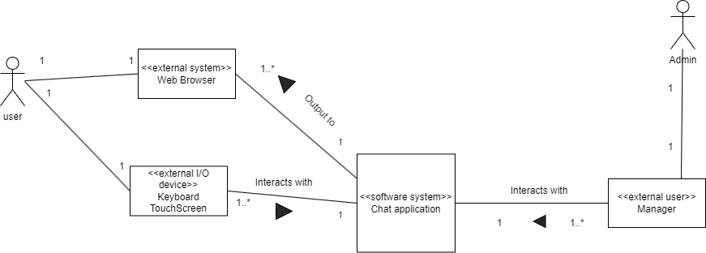

* 1. Total context diagram

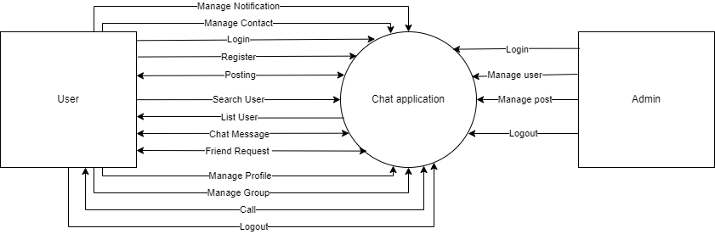

1. **USE CASE DIAGRAM**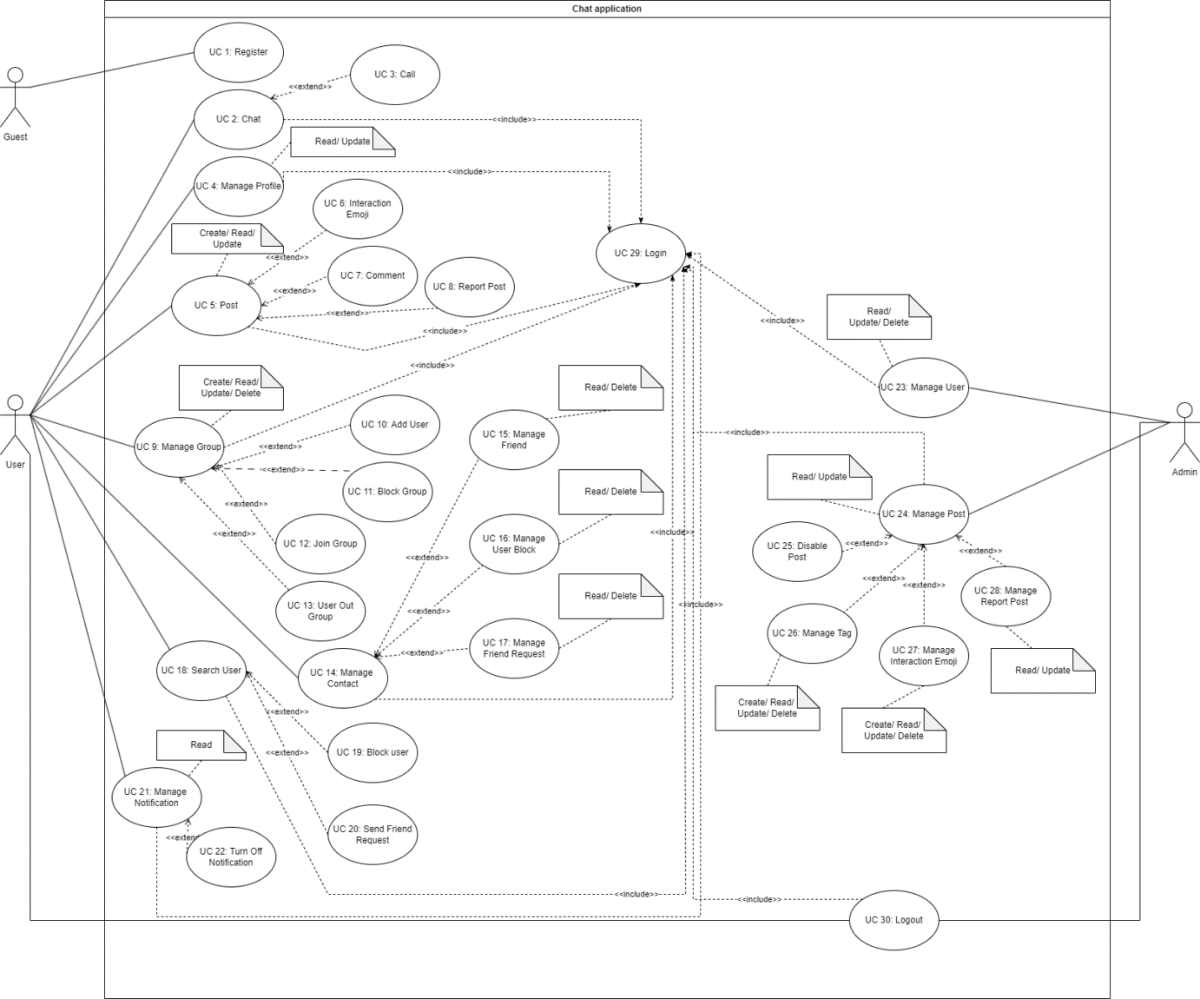
   1. Guest

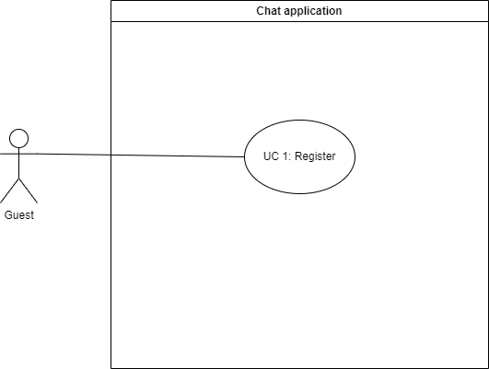

* 1. User

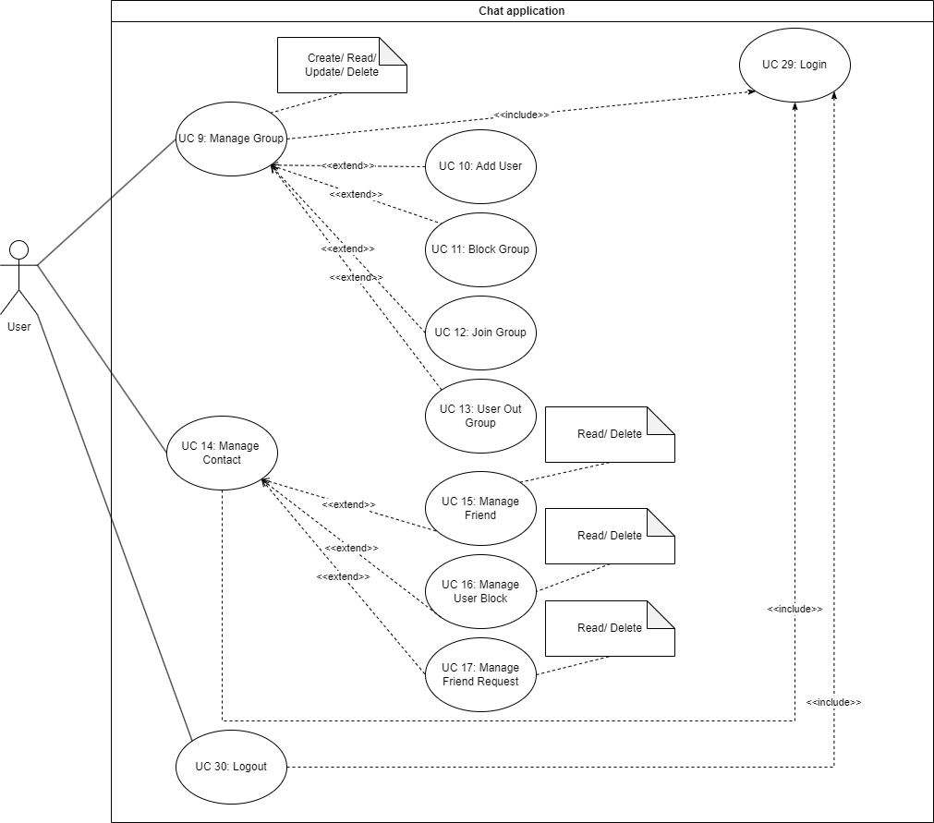

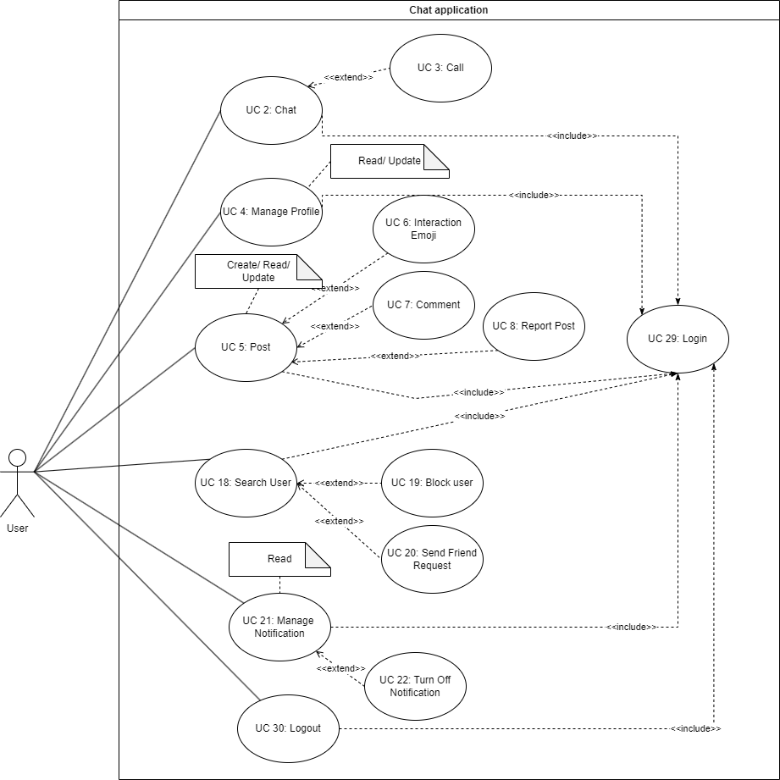

* 1. Admin

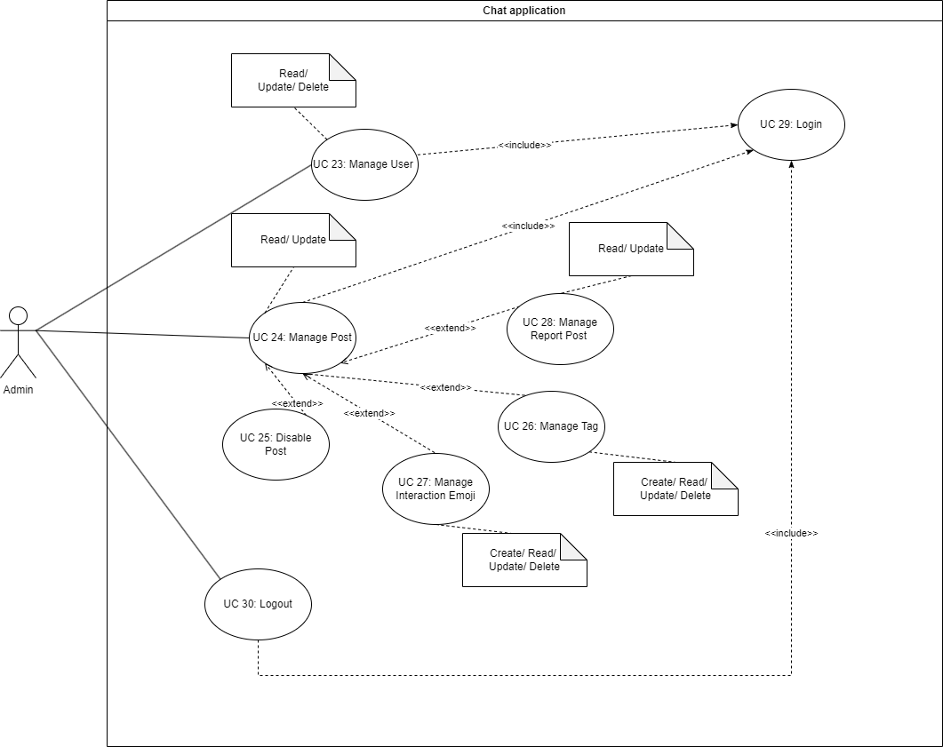

1. **ENITY CLASS DIAGRAM**

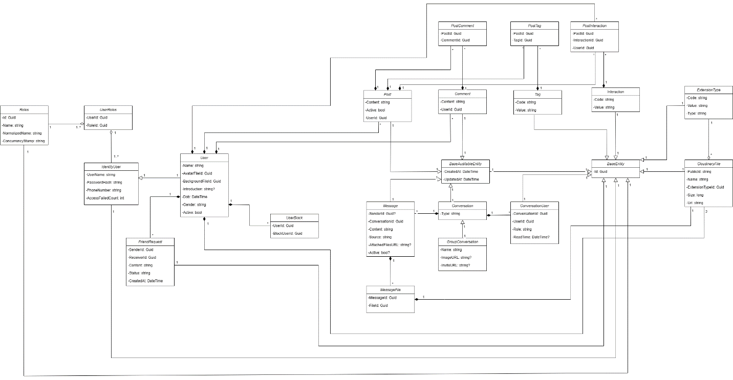

1. **SEQUENCE DIAGRAM**
   1. **Conversation**
      1. **CreateGroupConversation**

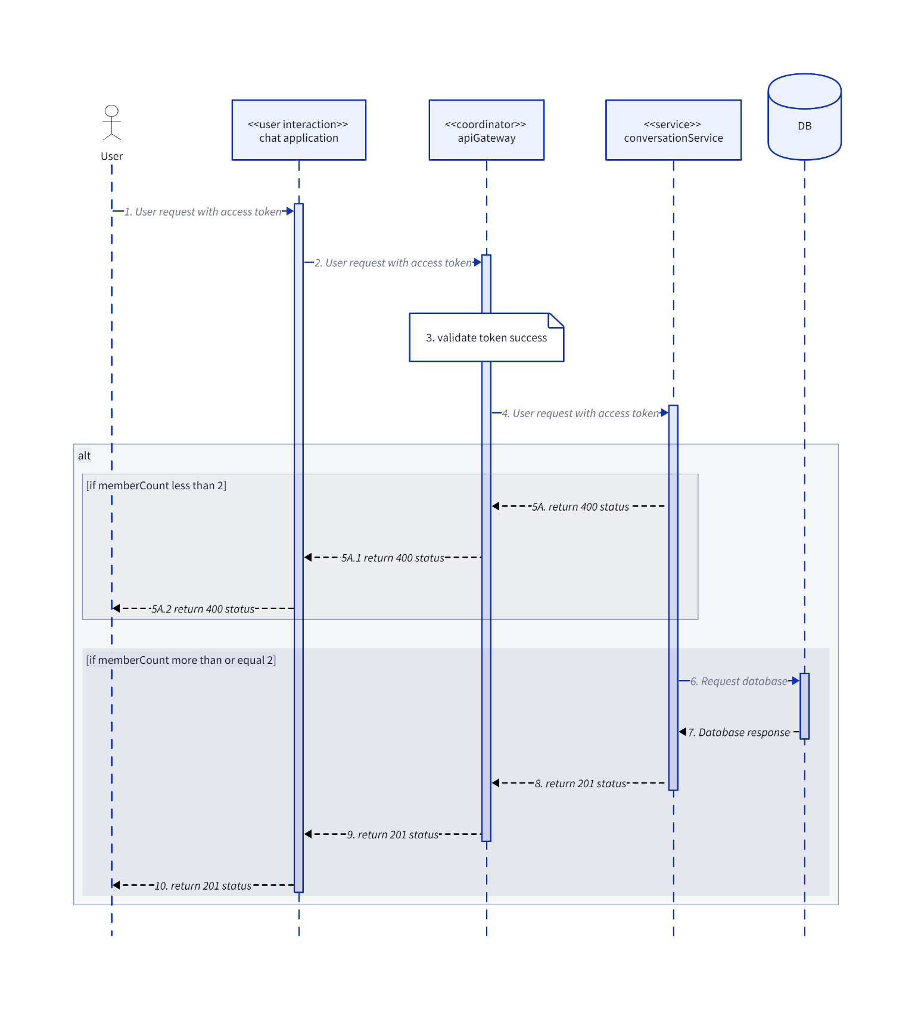

* + 1. **DeleteConversation**

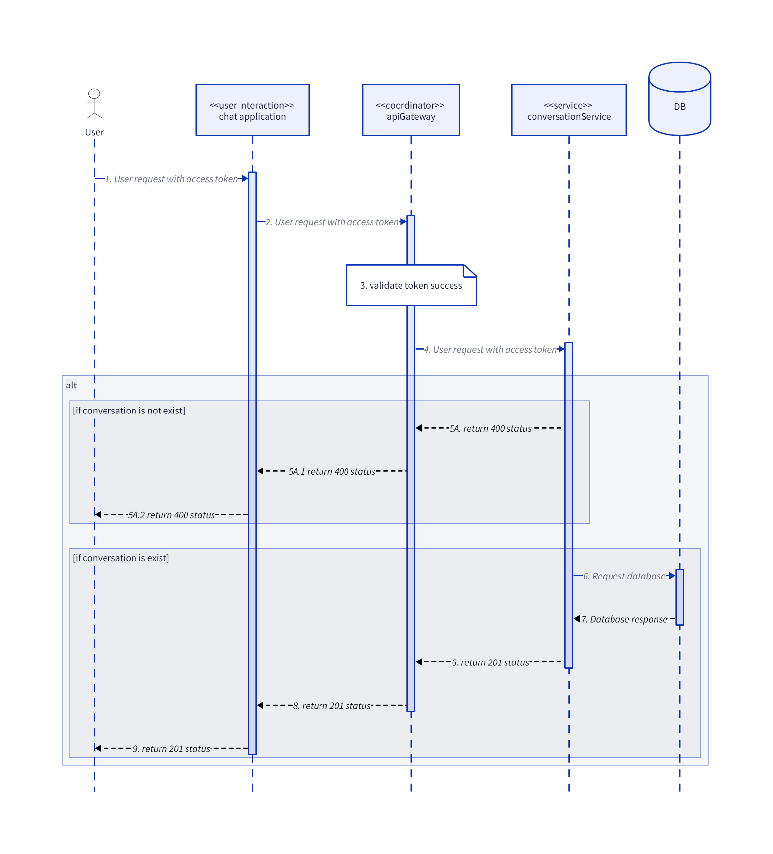

* + 1. **GetConversation**

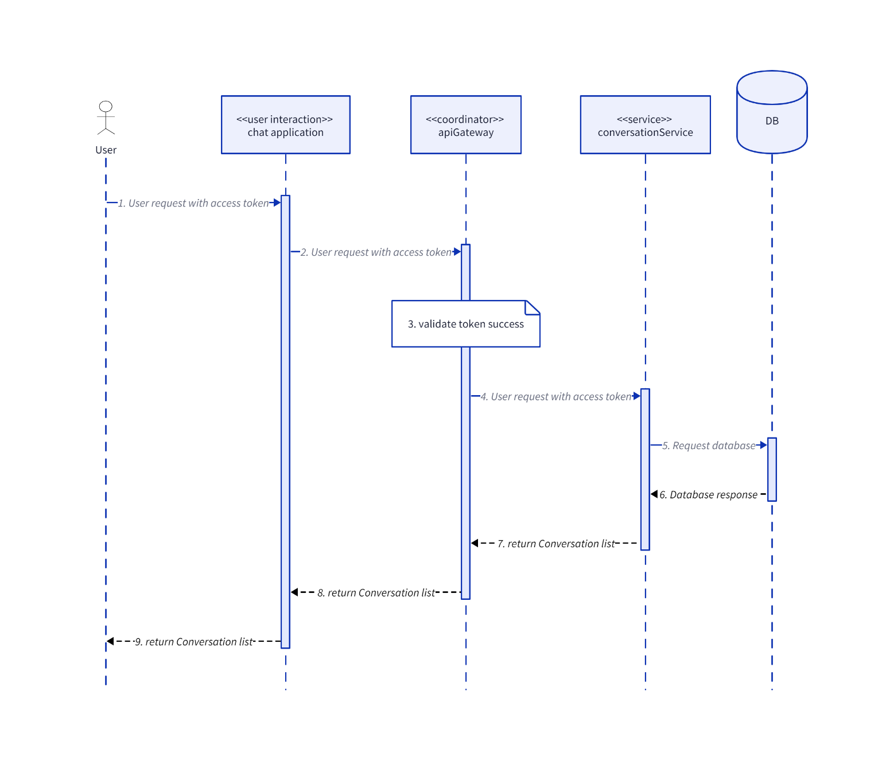

* + 1. **GetMemberListByConversationId**

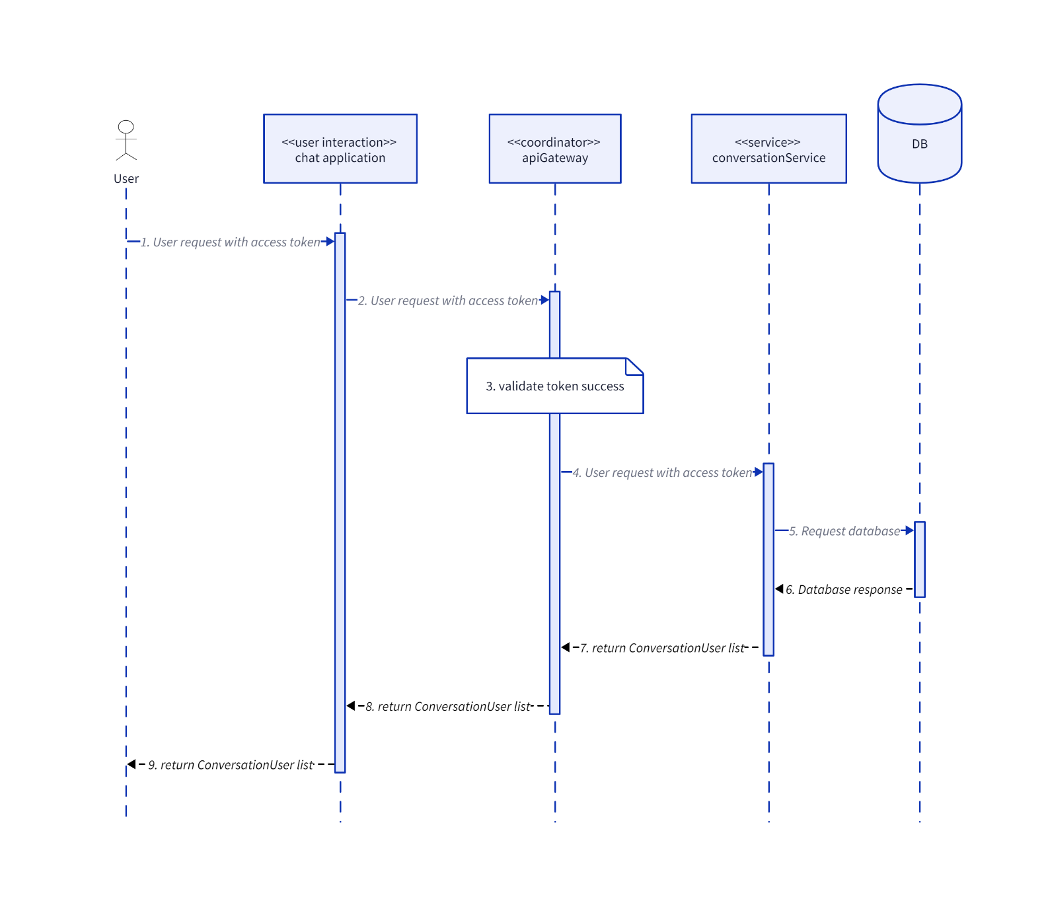

* + 1. **GroupAddUser**

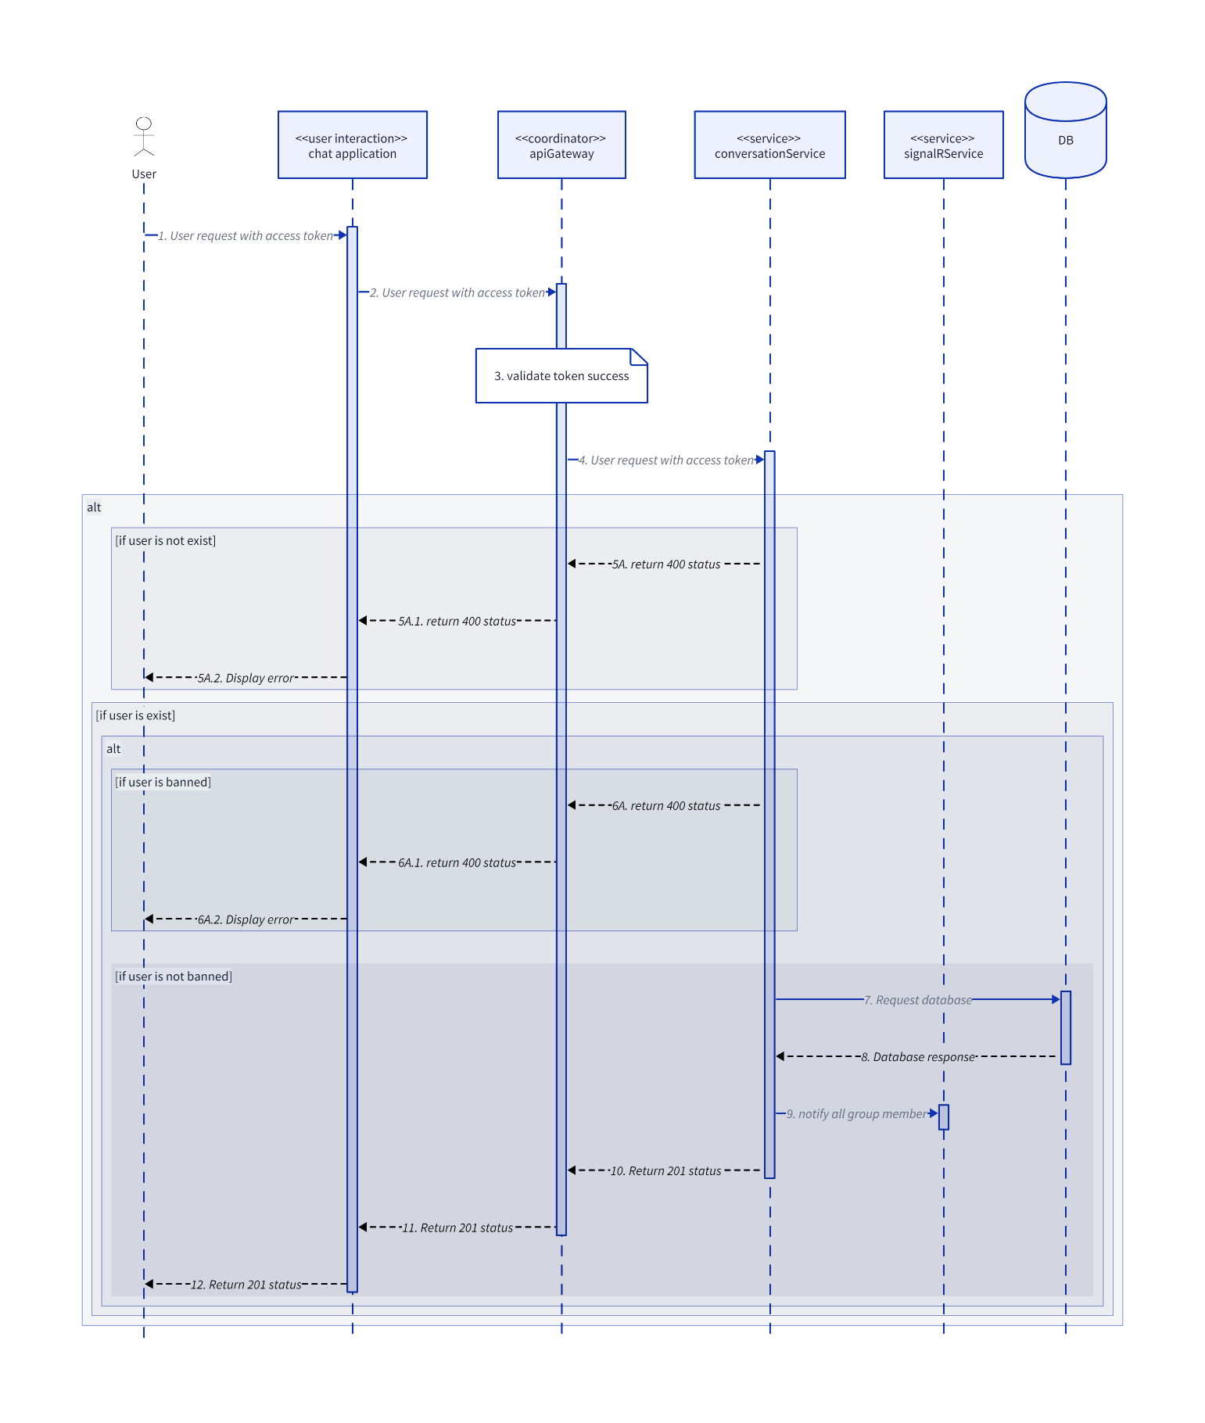

* + 1. **GroupBlockUser**

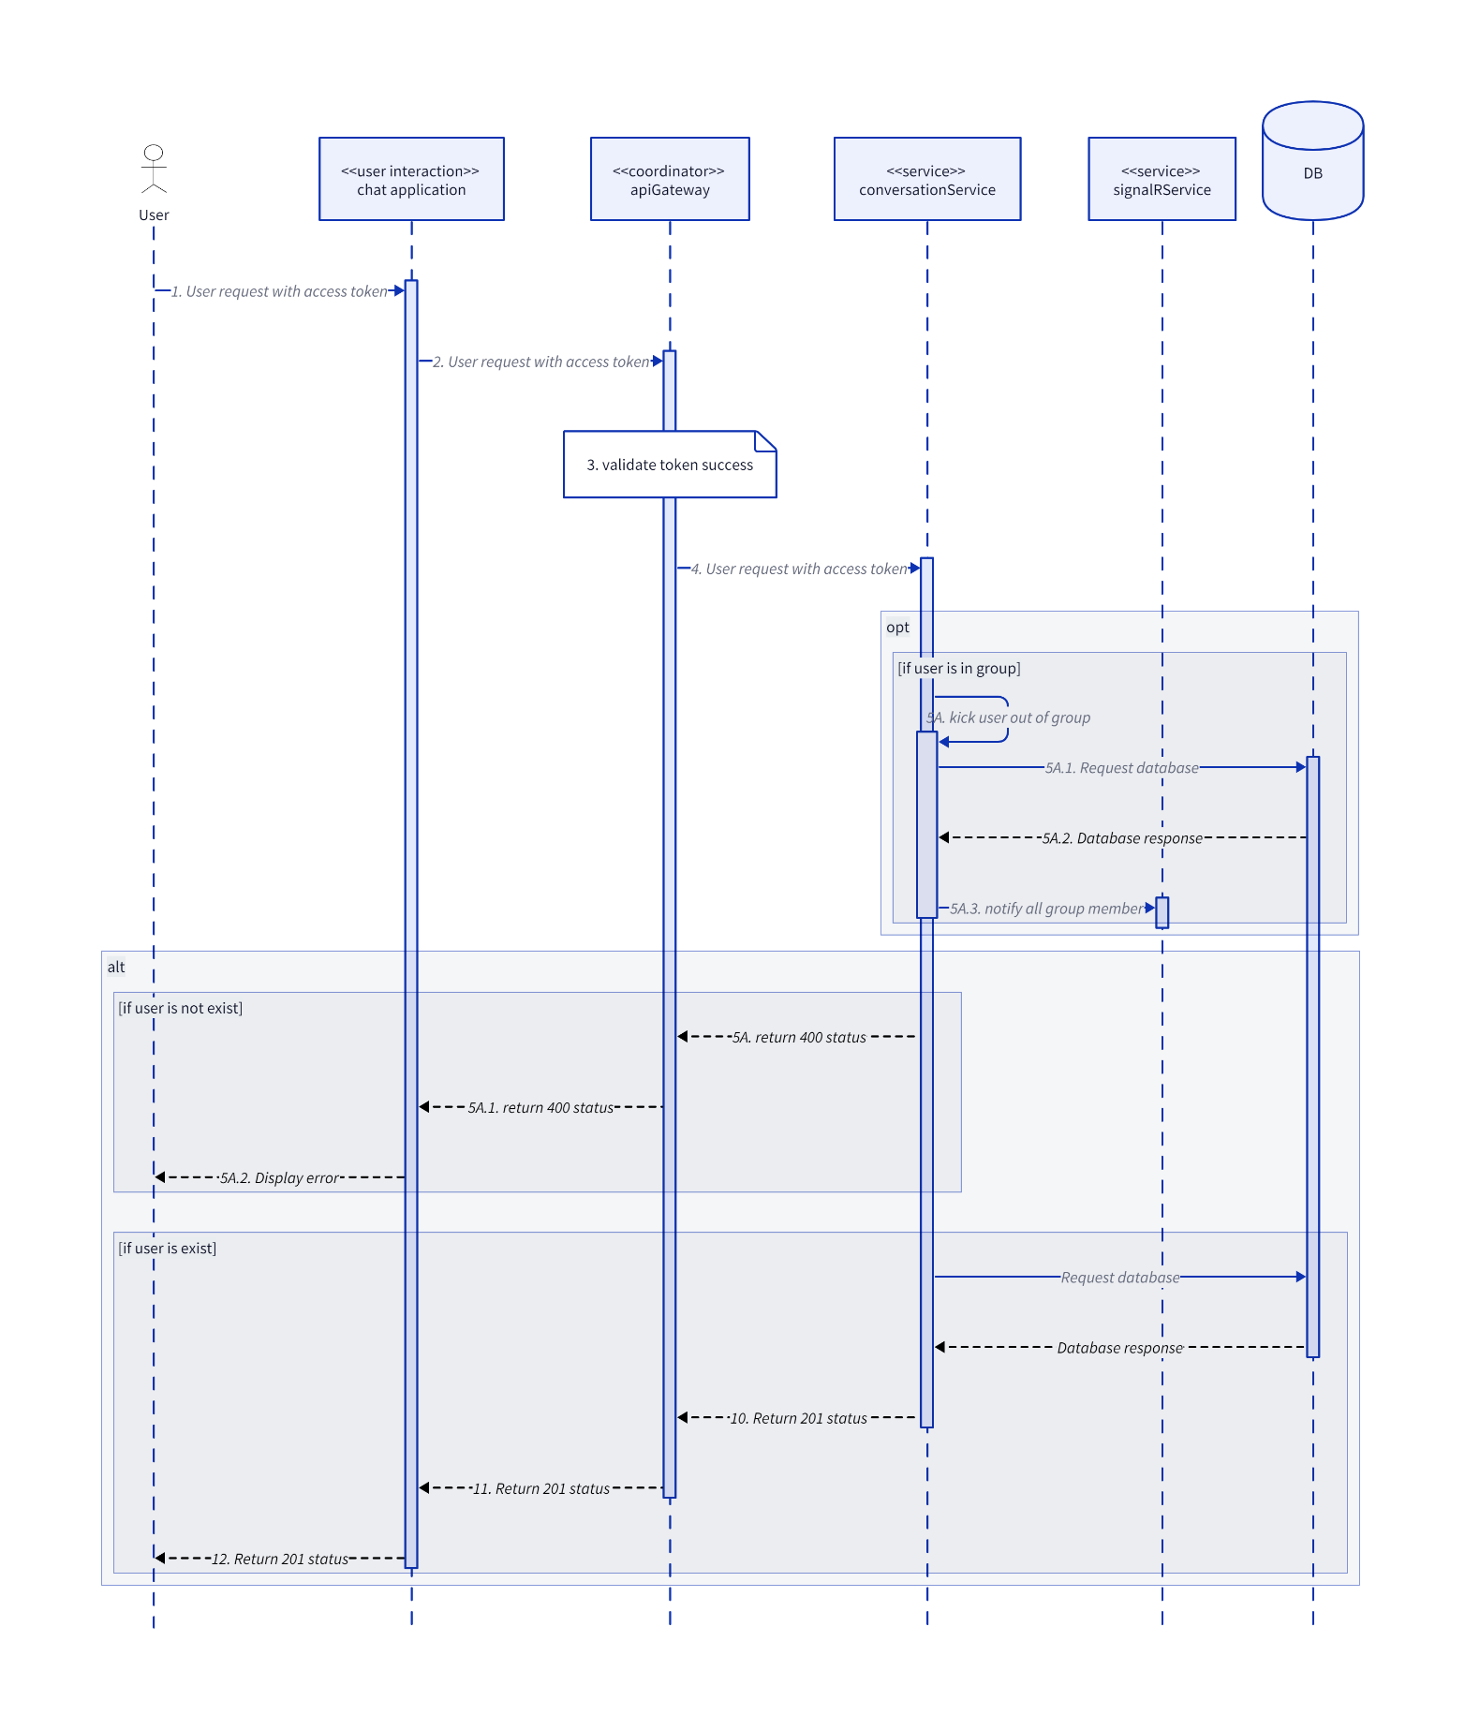

* + 1. **GroupDisband**

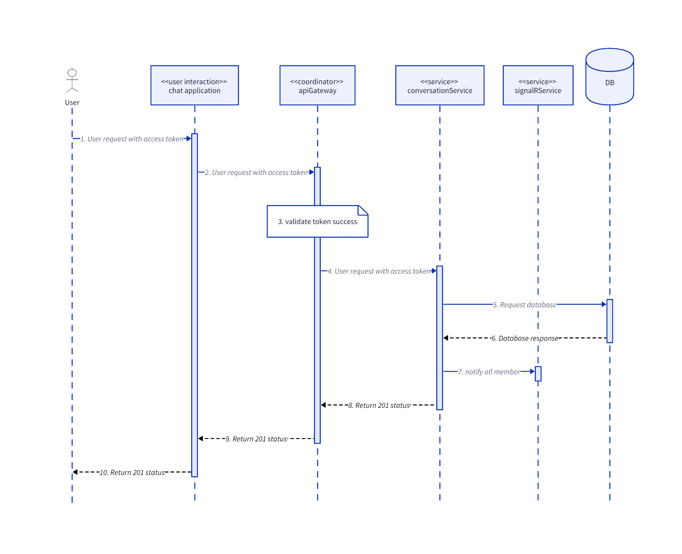

* + 1. **SendClientMessage**

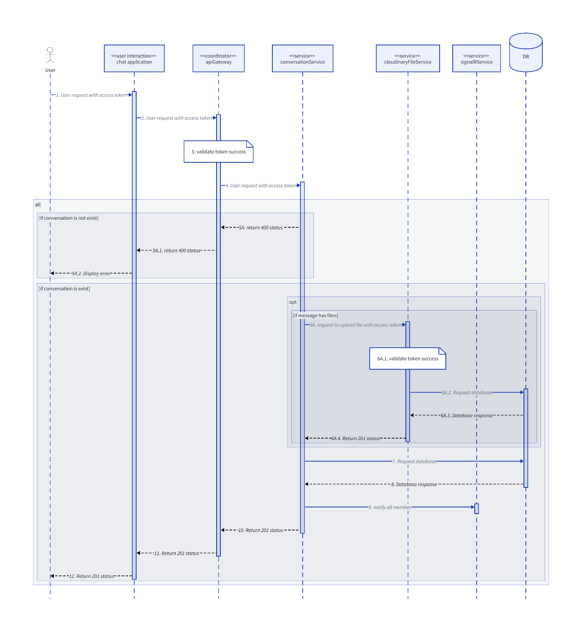

* + 1. **UpdateGroupConversation**

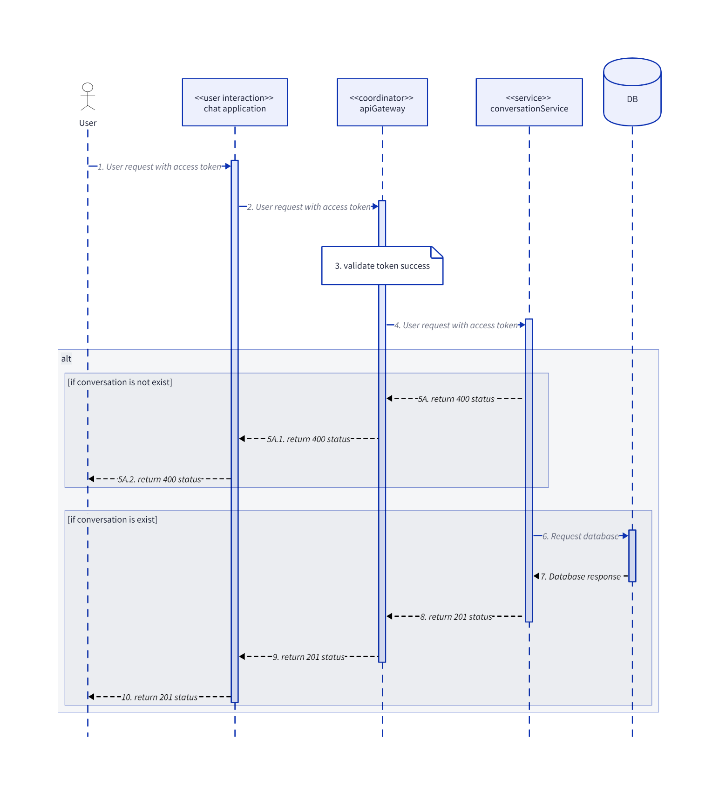

* + 1. **UserExitGroup**

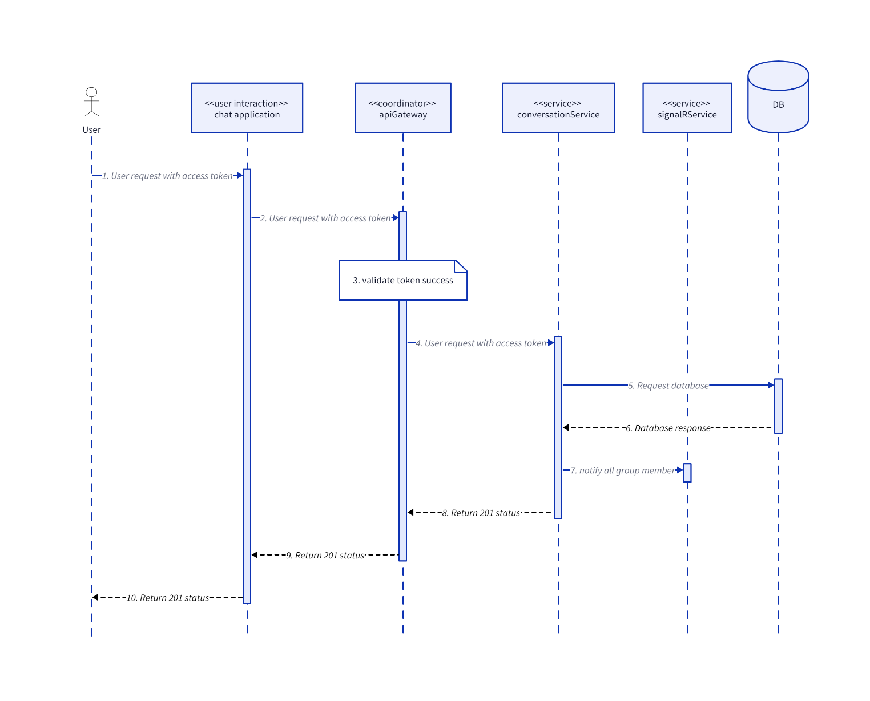

* + 1. **UserJoinGroup**

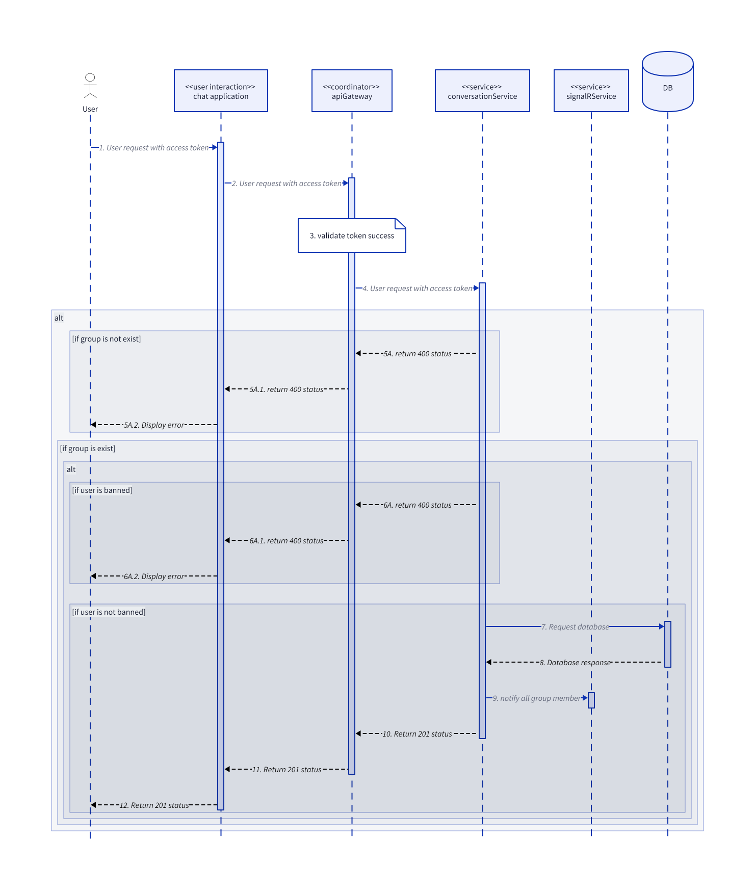

* 1. **Identity**
     1. **AcceptFriendRequest**

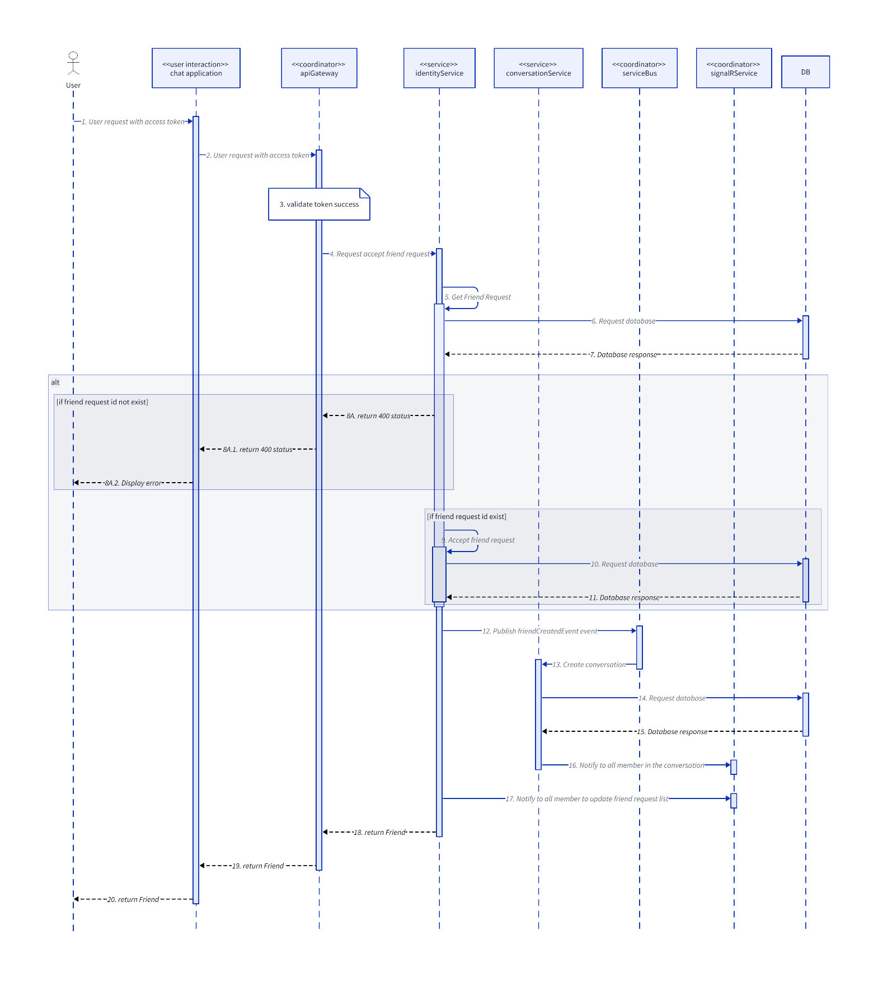

* + 1. **BlockUser**

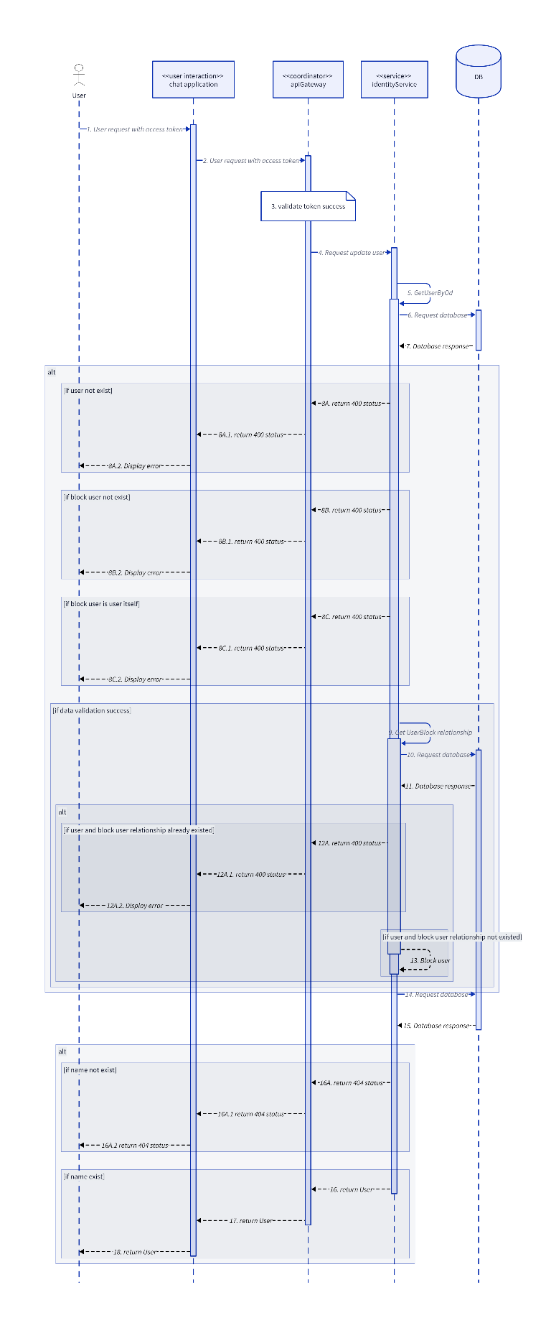

* + 1. **DeleteFriend**

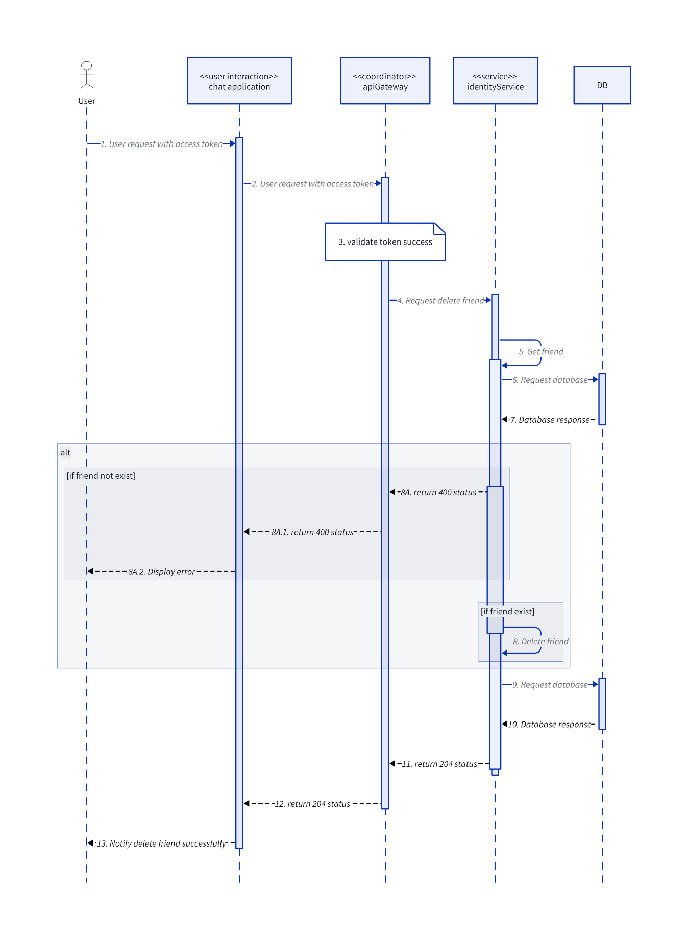

* + 1. **DeleteFriendRequest**

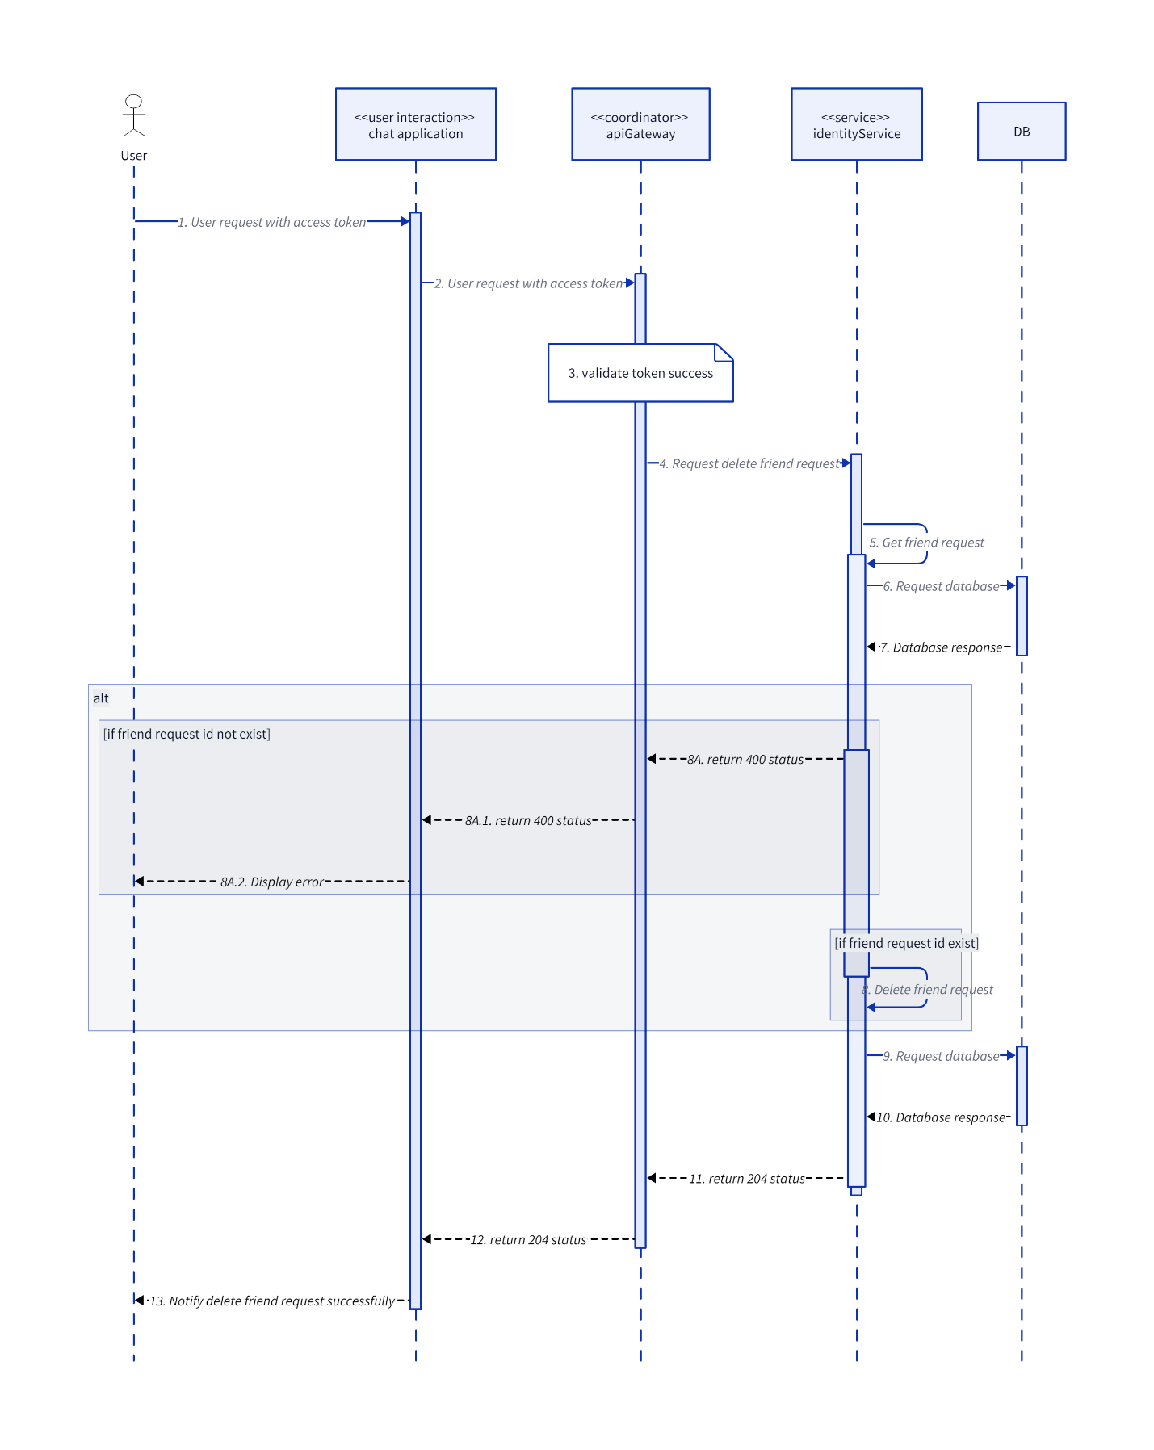

* + 1. **GetFriendListByUserId**

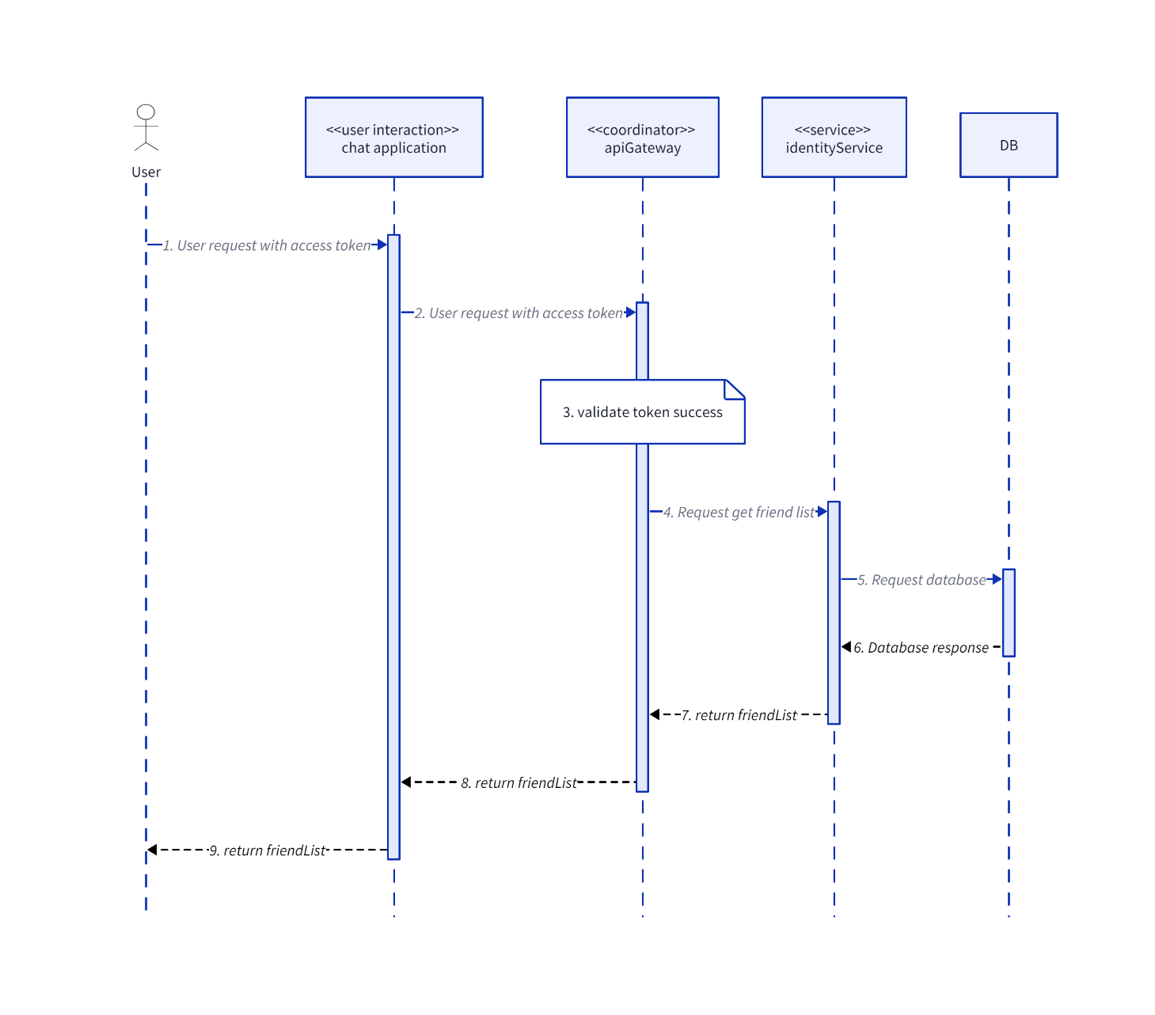

* + 1. **GetFriendRequestByUserId**

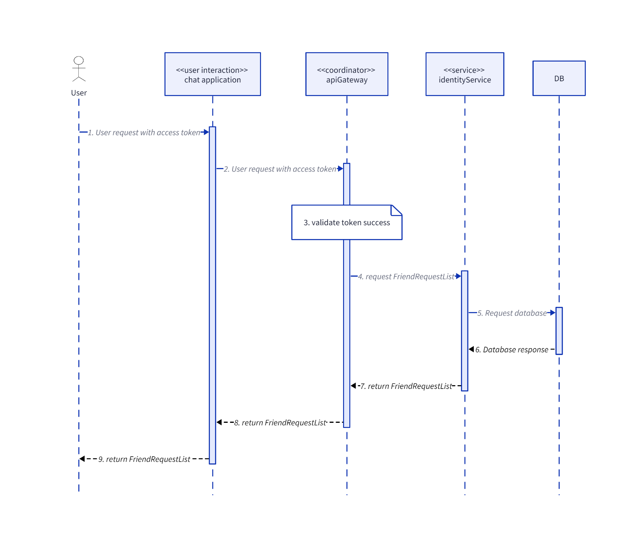

* + 1. **GetUserById**

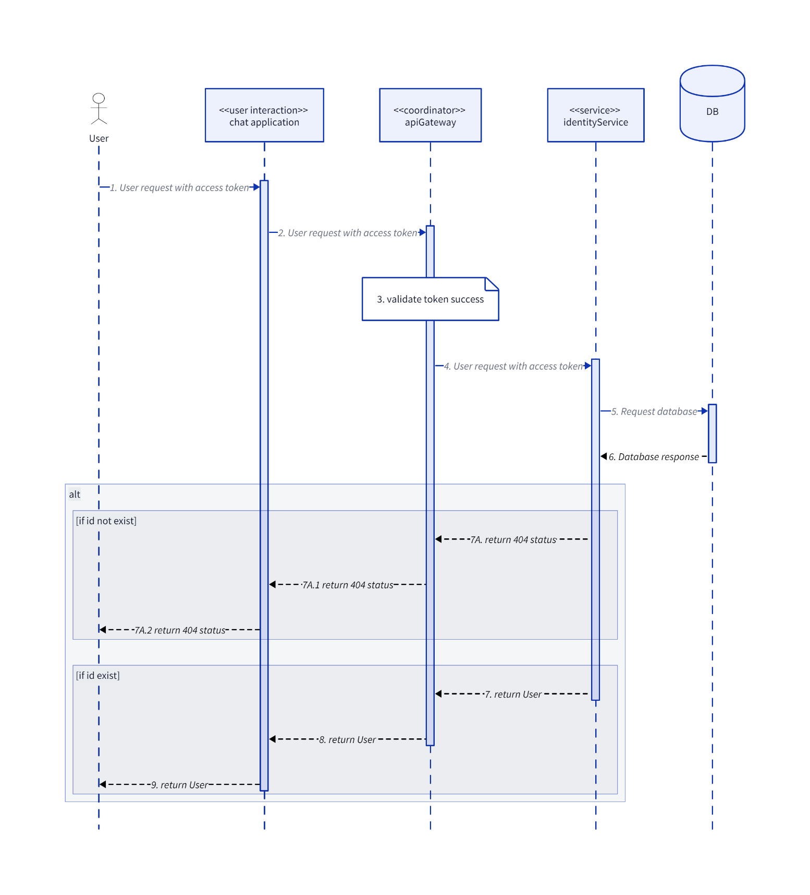

* + 1. **HelperSequenceDiagram**

**UserUnauthorized**

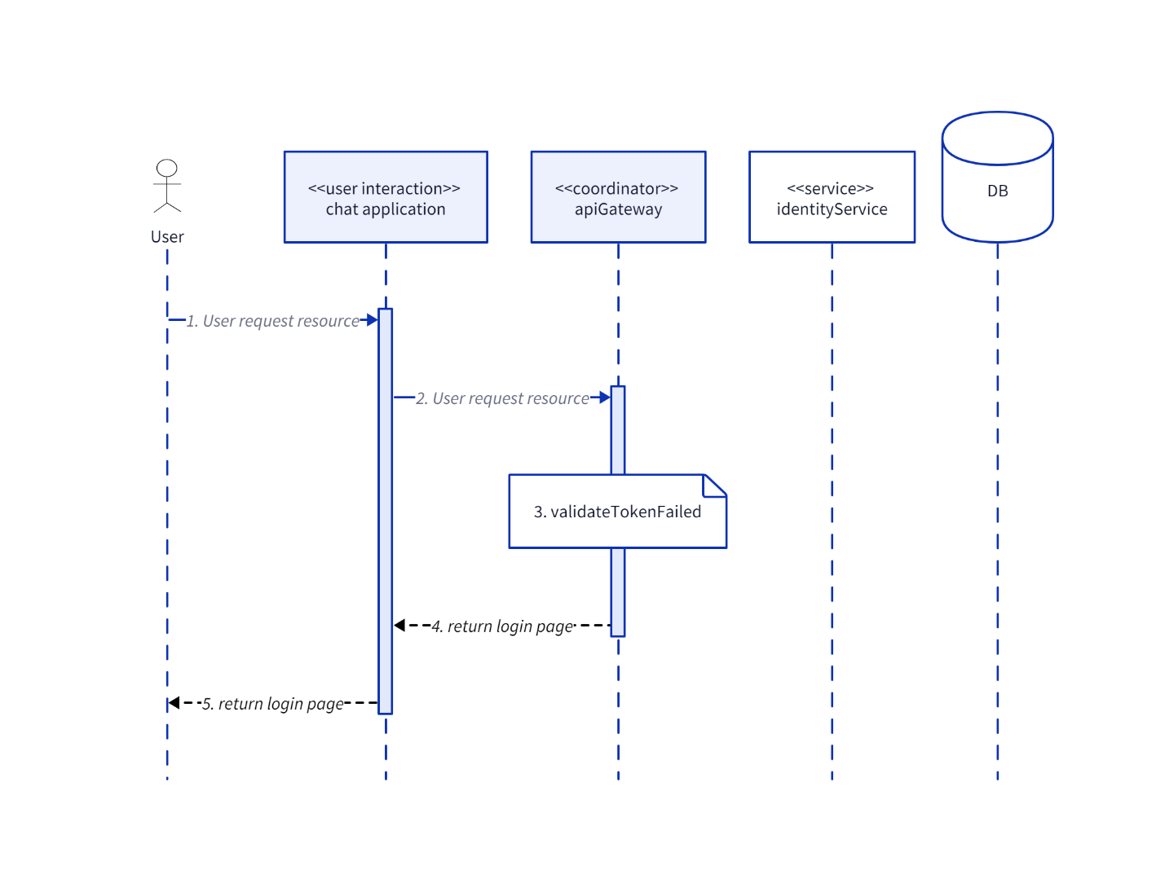

**ValidateToken**

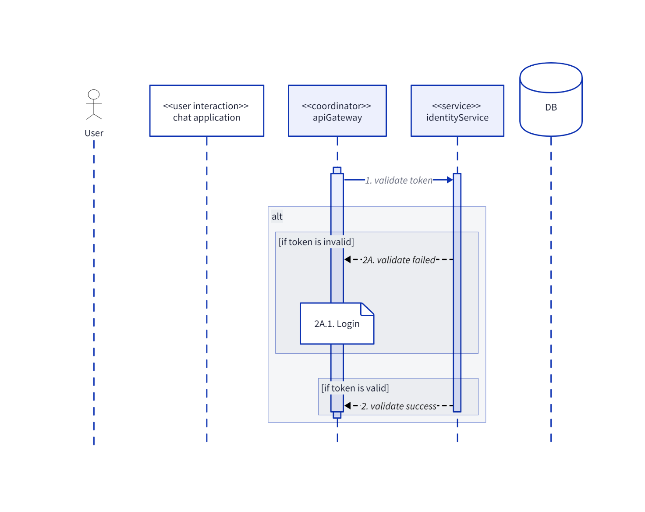

* + 1. **Login**
    2. **Register**

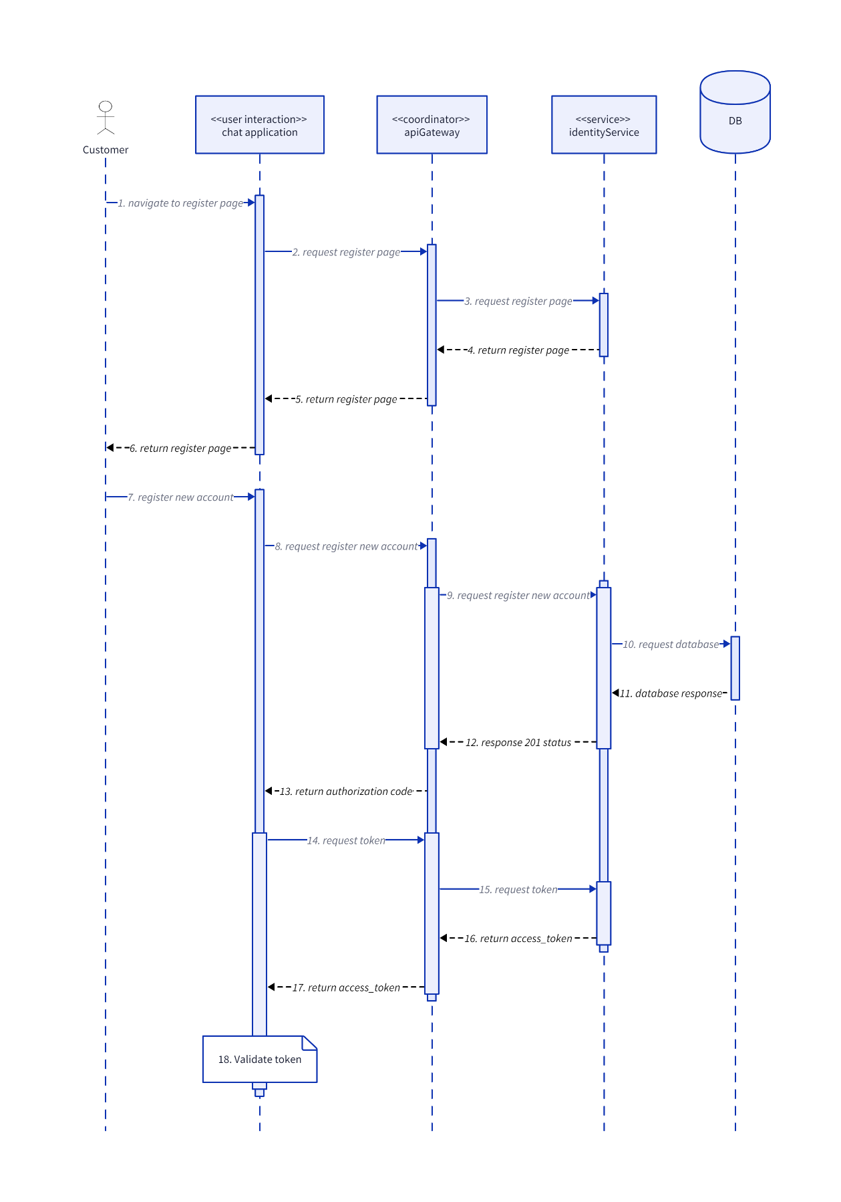

* + 1. **SearchUser**

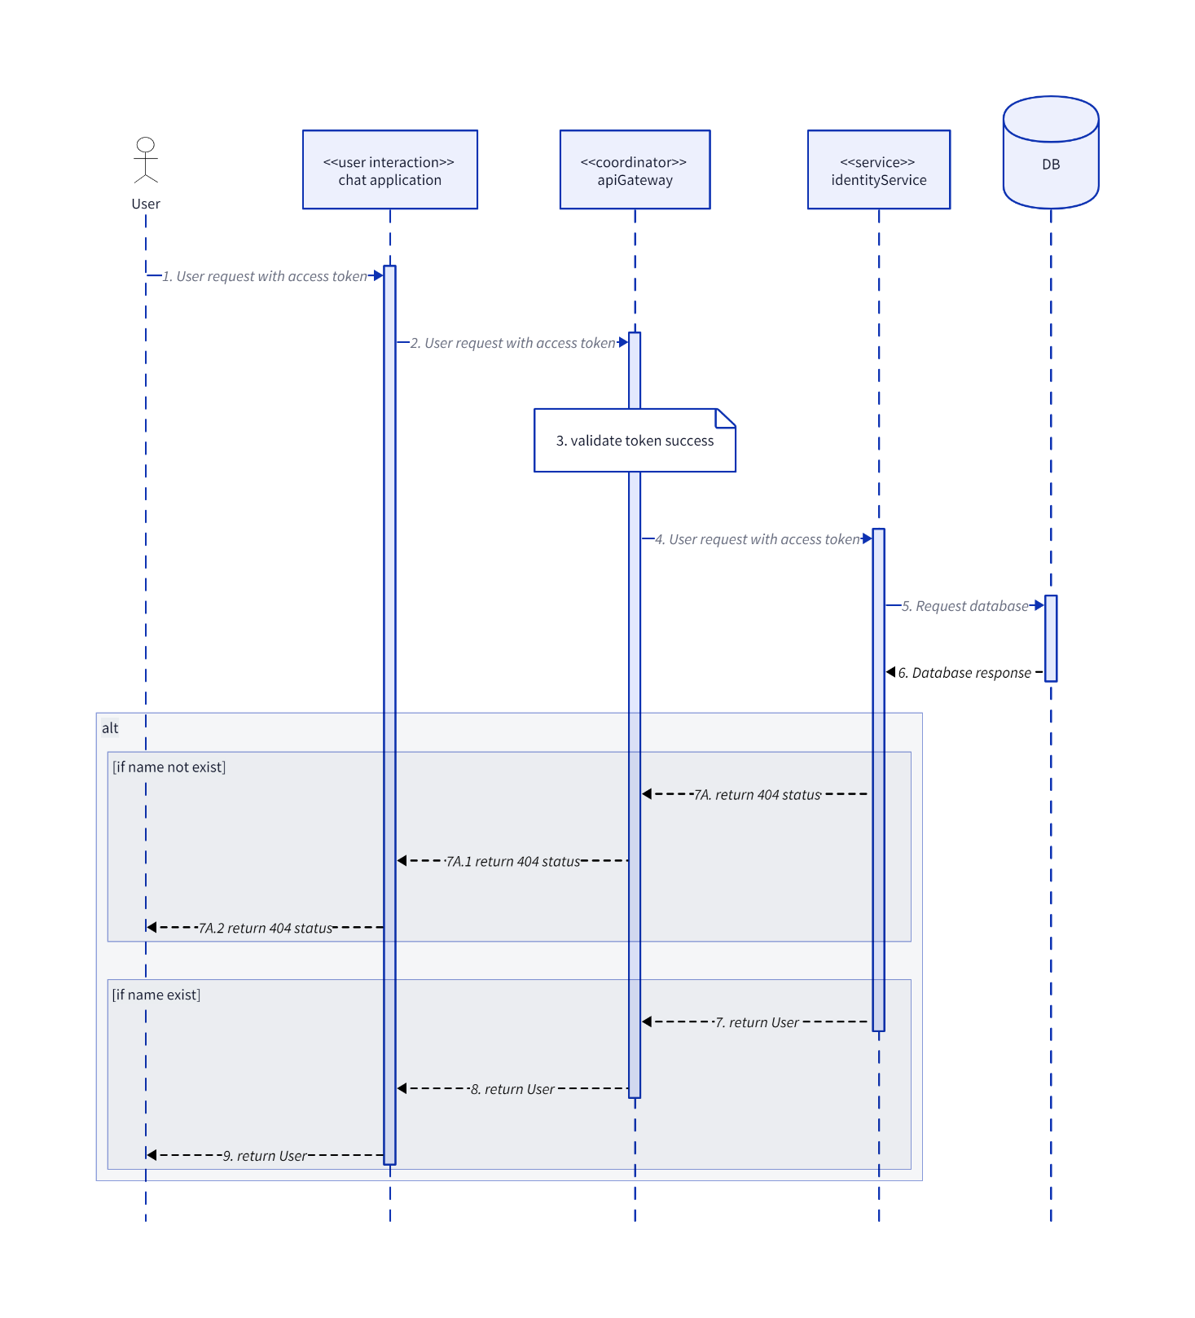

* + 1. **SendFriendRequest**

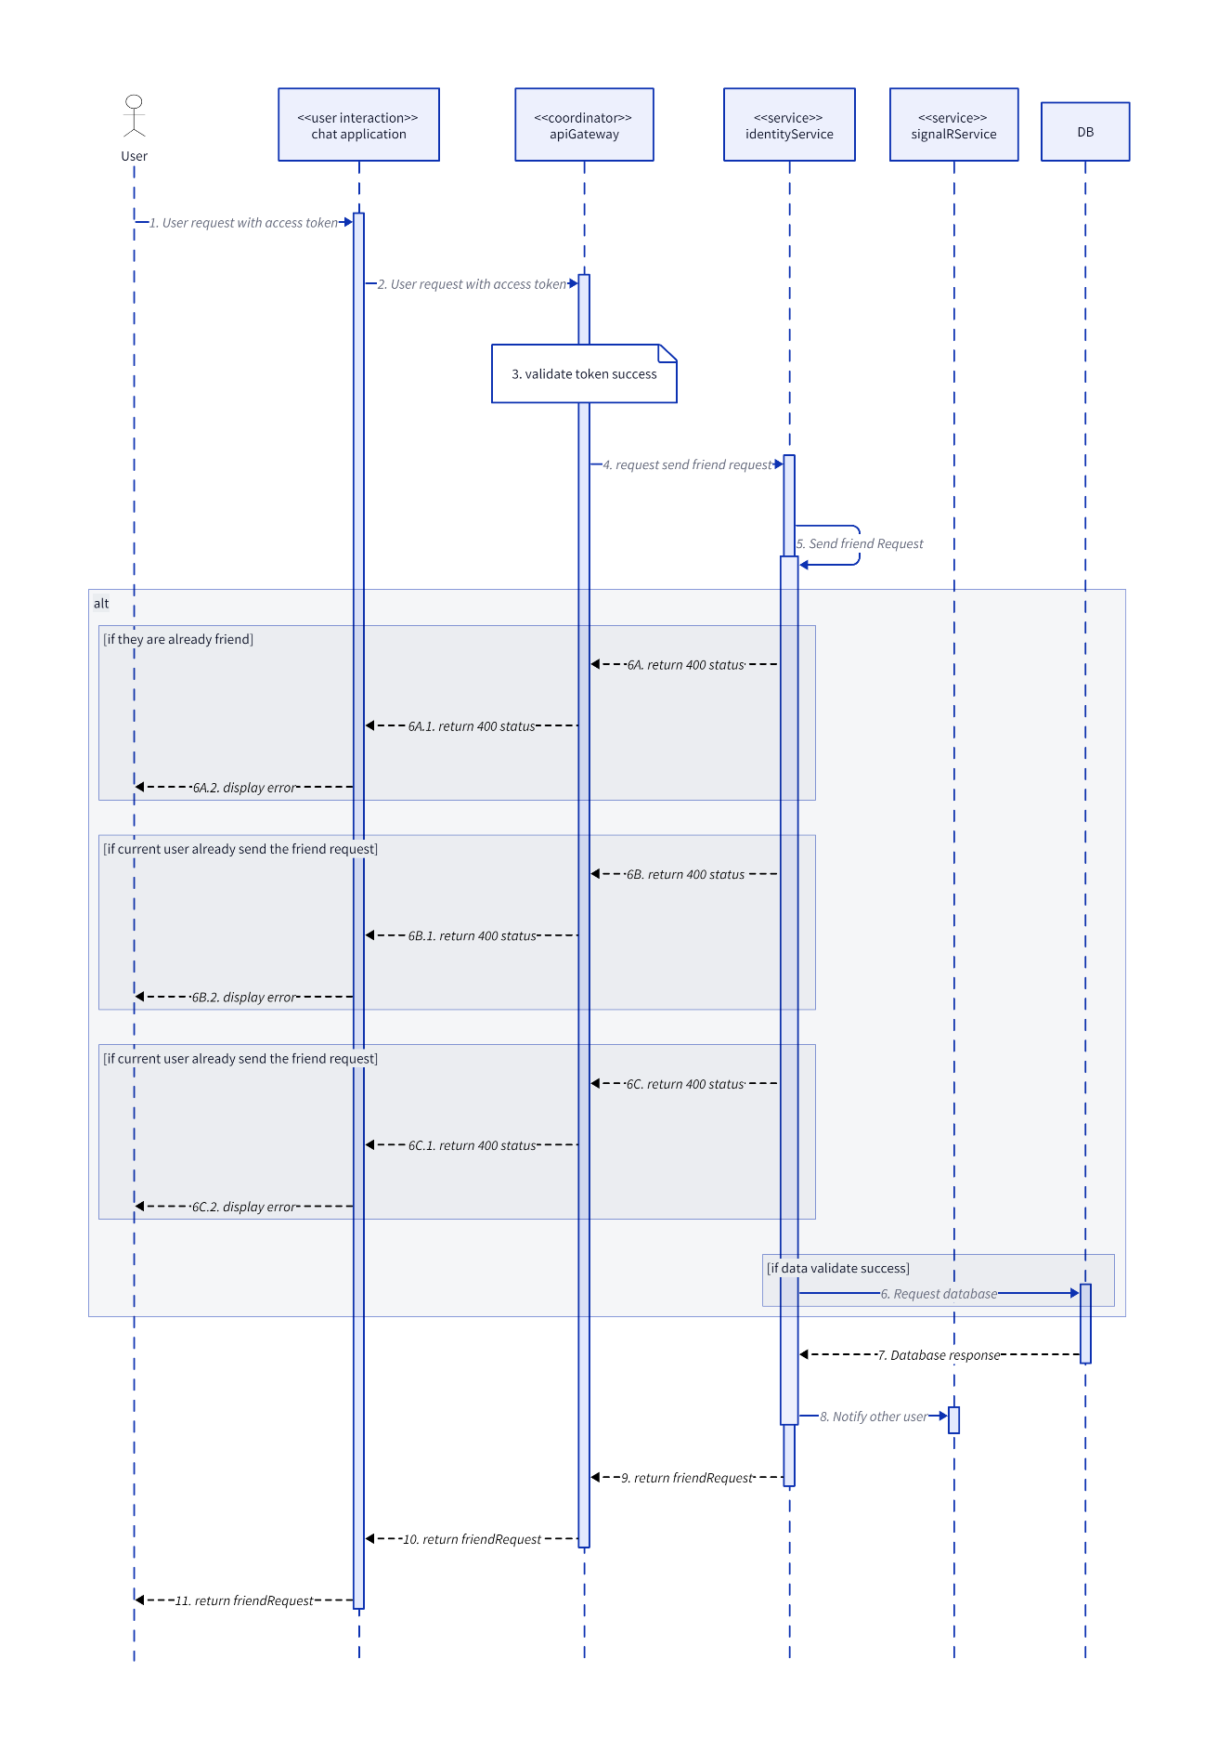

* + 1. **UnblockUser**

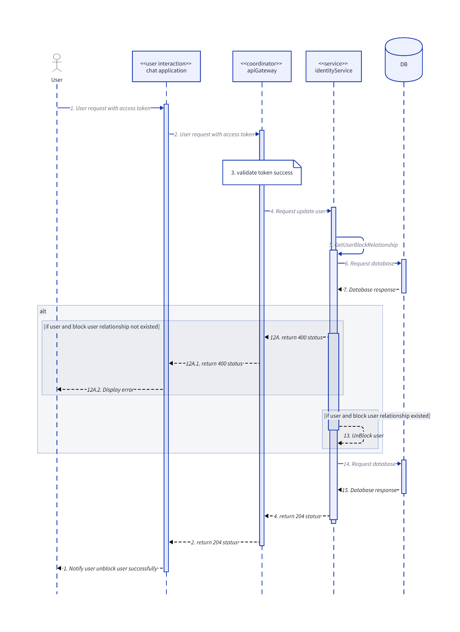

* + 1. **UpdateUser**

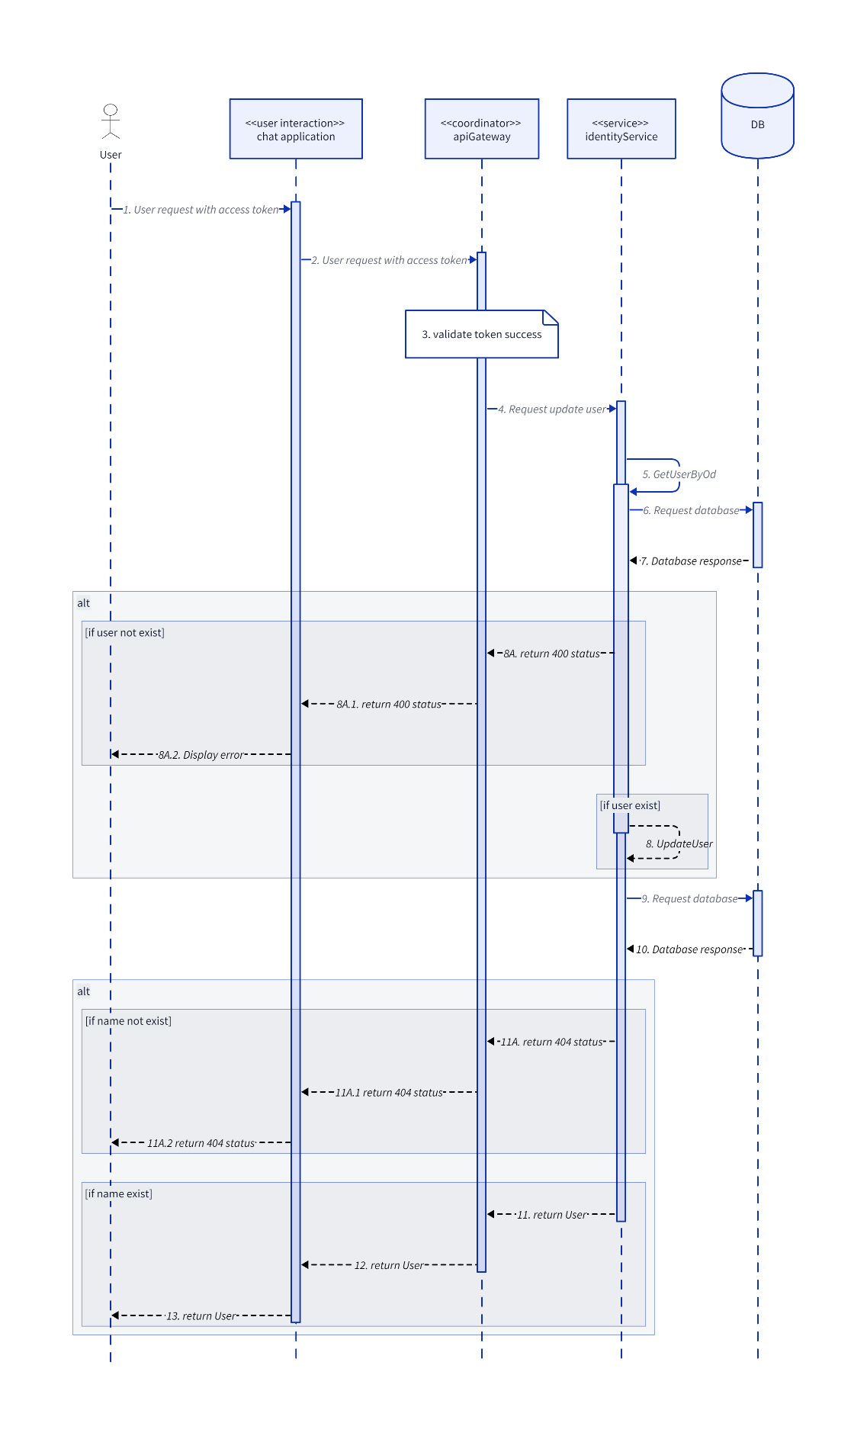

* 1. **Notification**
     1. **UpdateNotificationStatus**

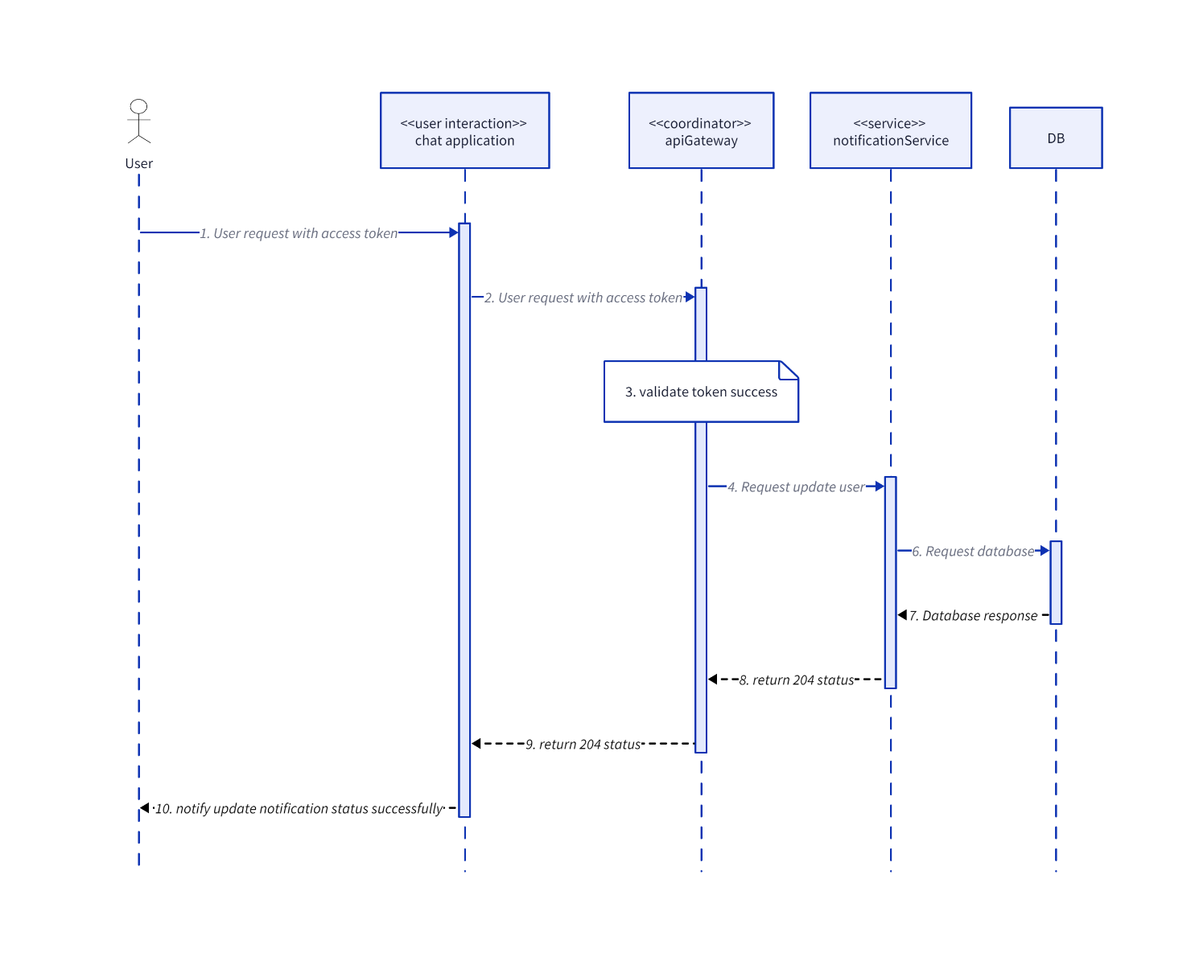

* 1. **Post**
     1. **CreateComment**

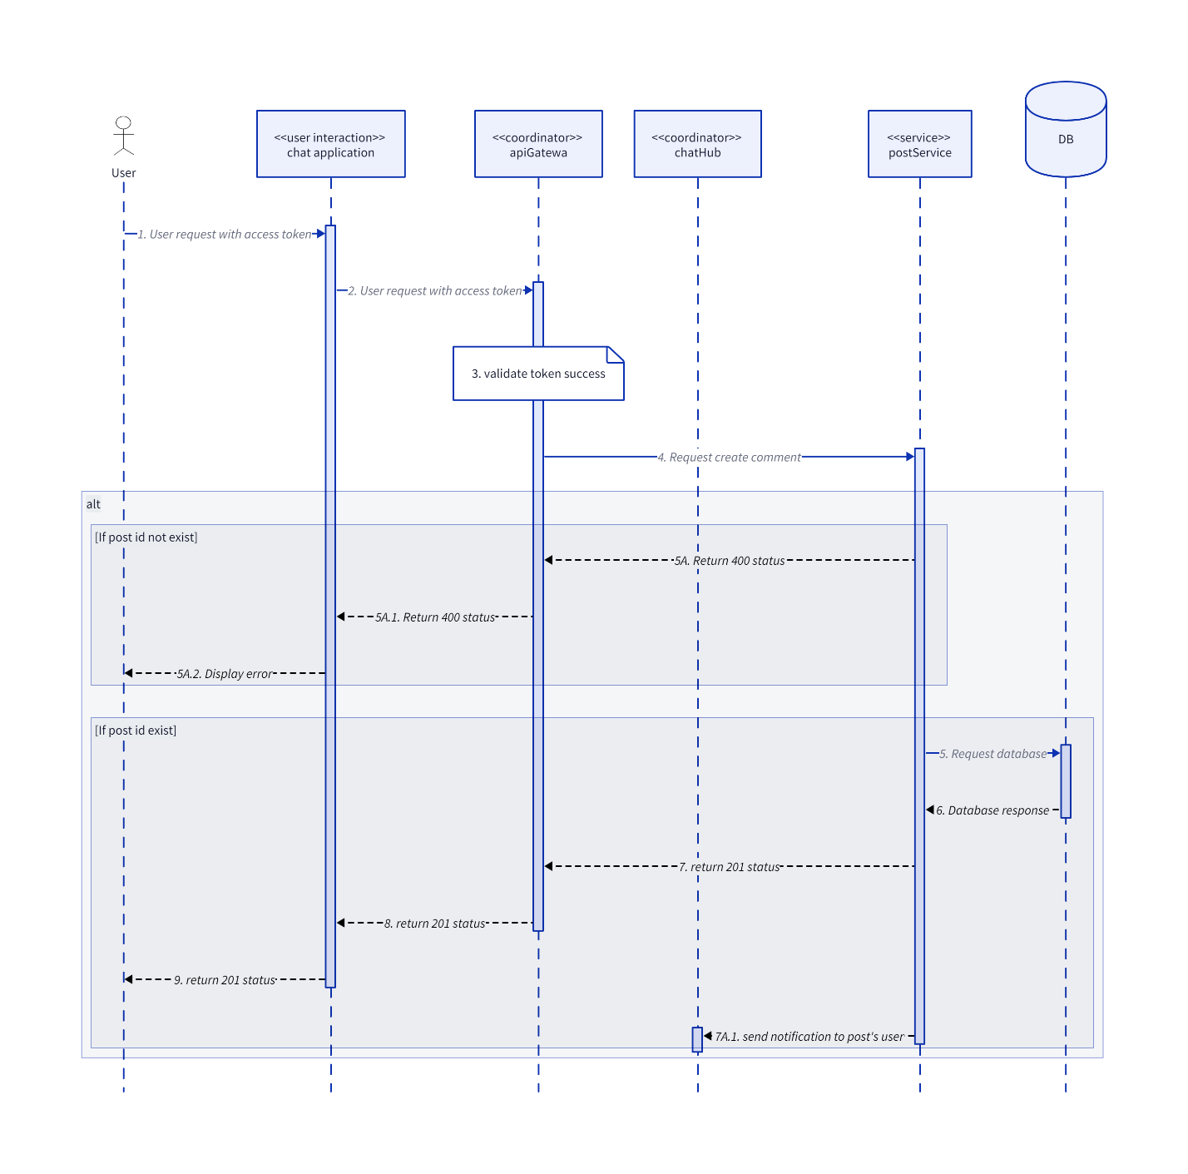

* + 1. **CreateInteractionEmoji**

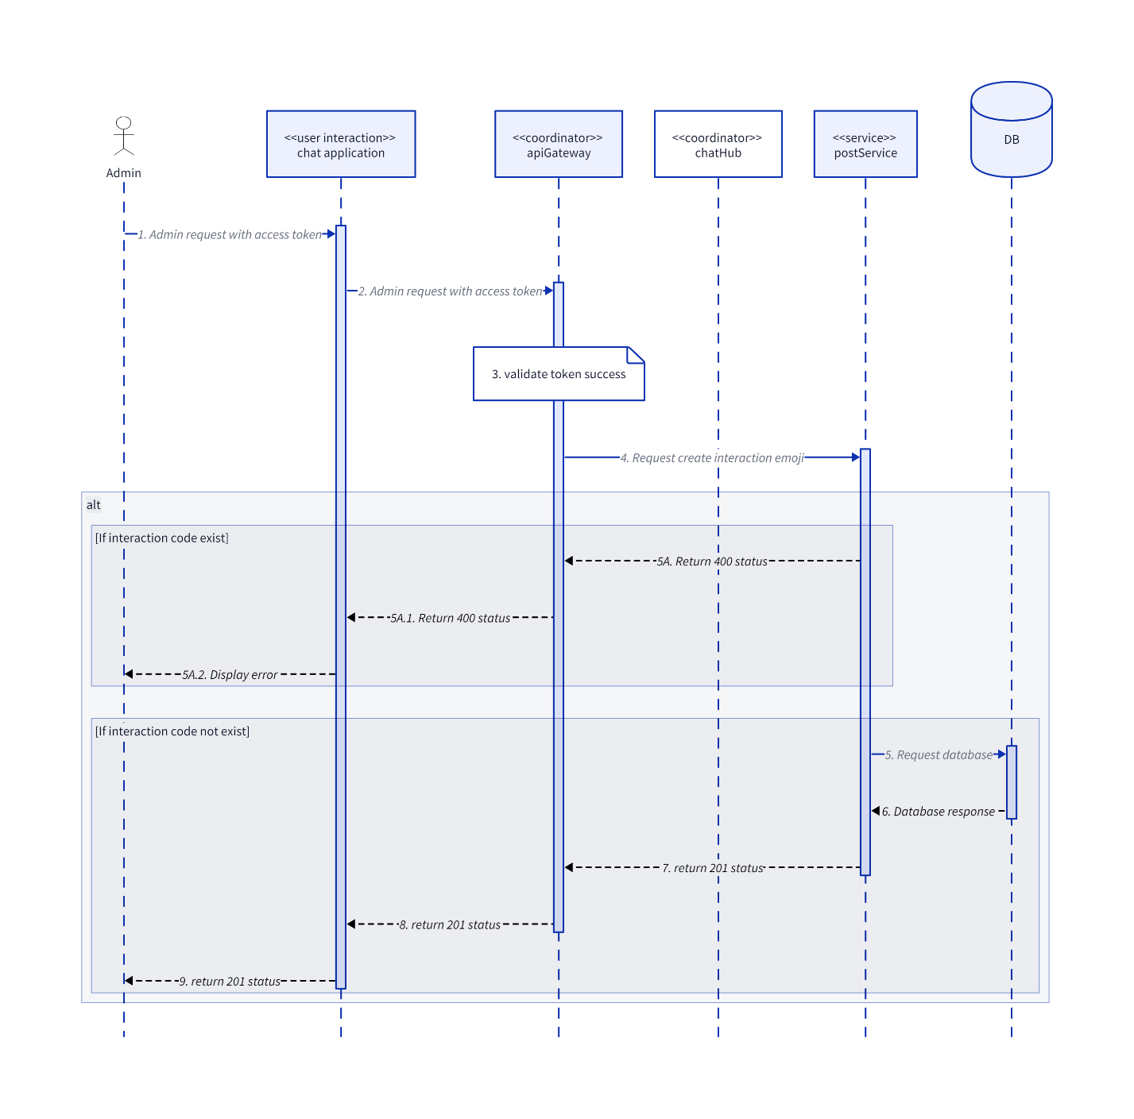

* + 1. **CreatePost**

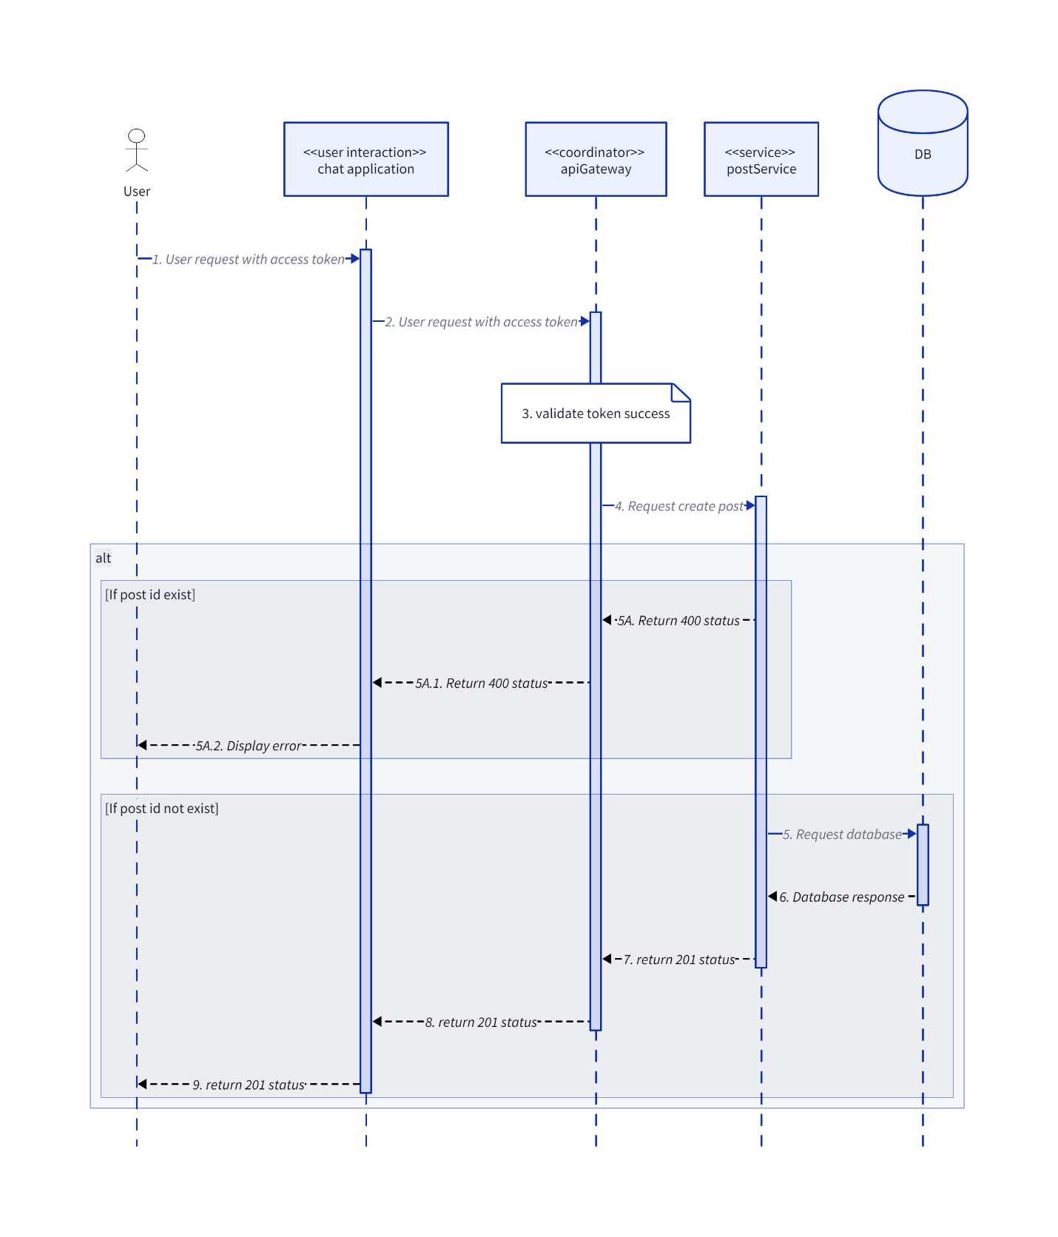

* + 1. **CreatePostInteraction**

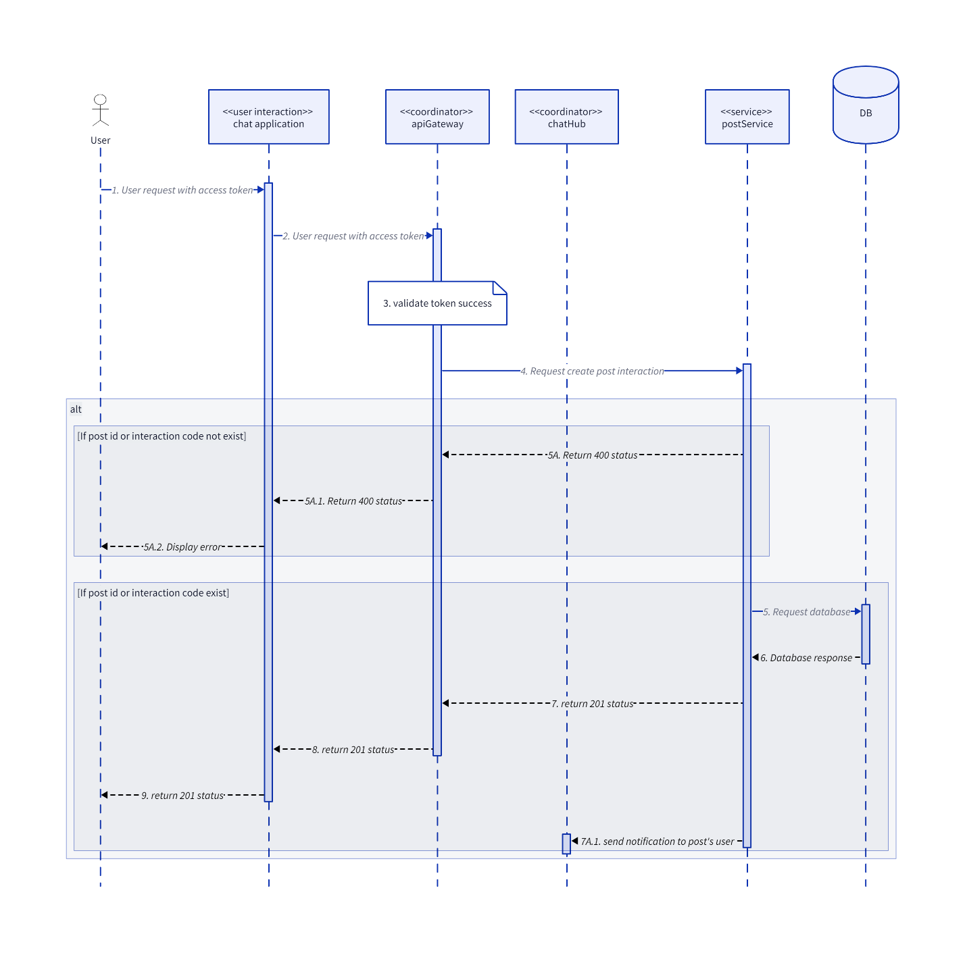

* + 1. **CreatePostReport**

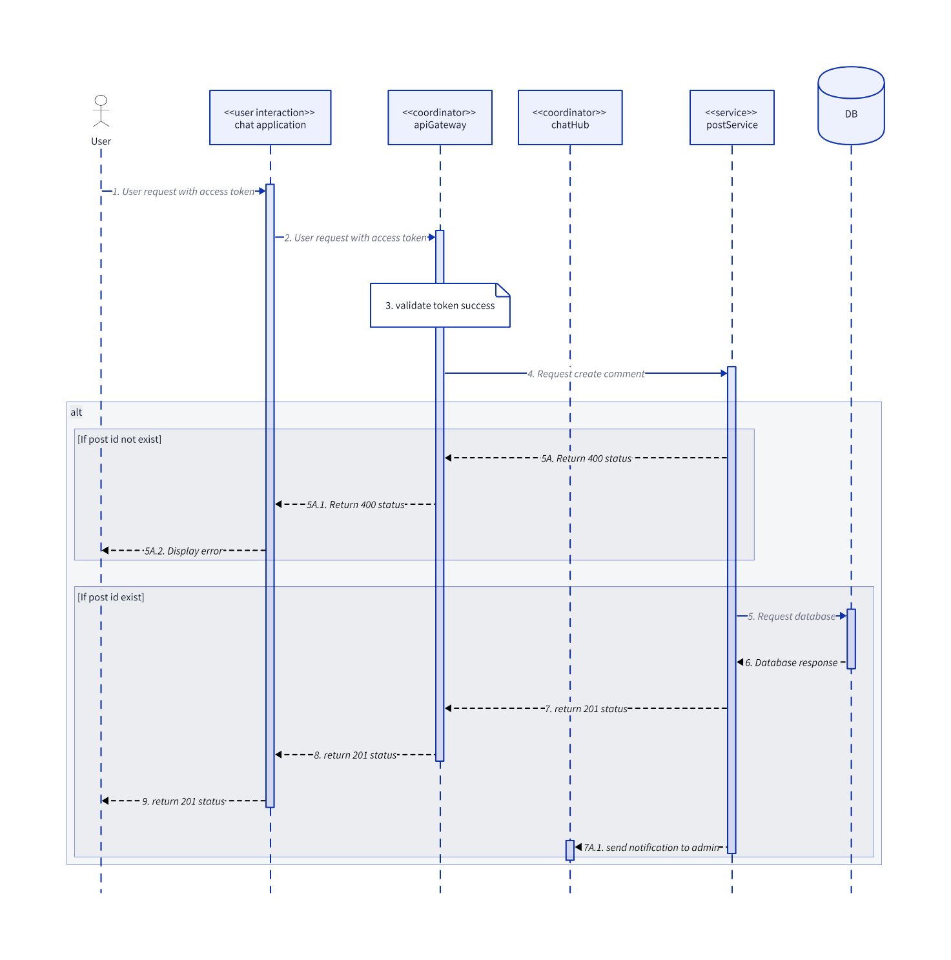

* + 1. **CreateTag**

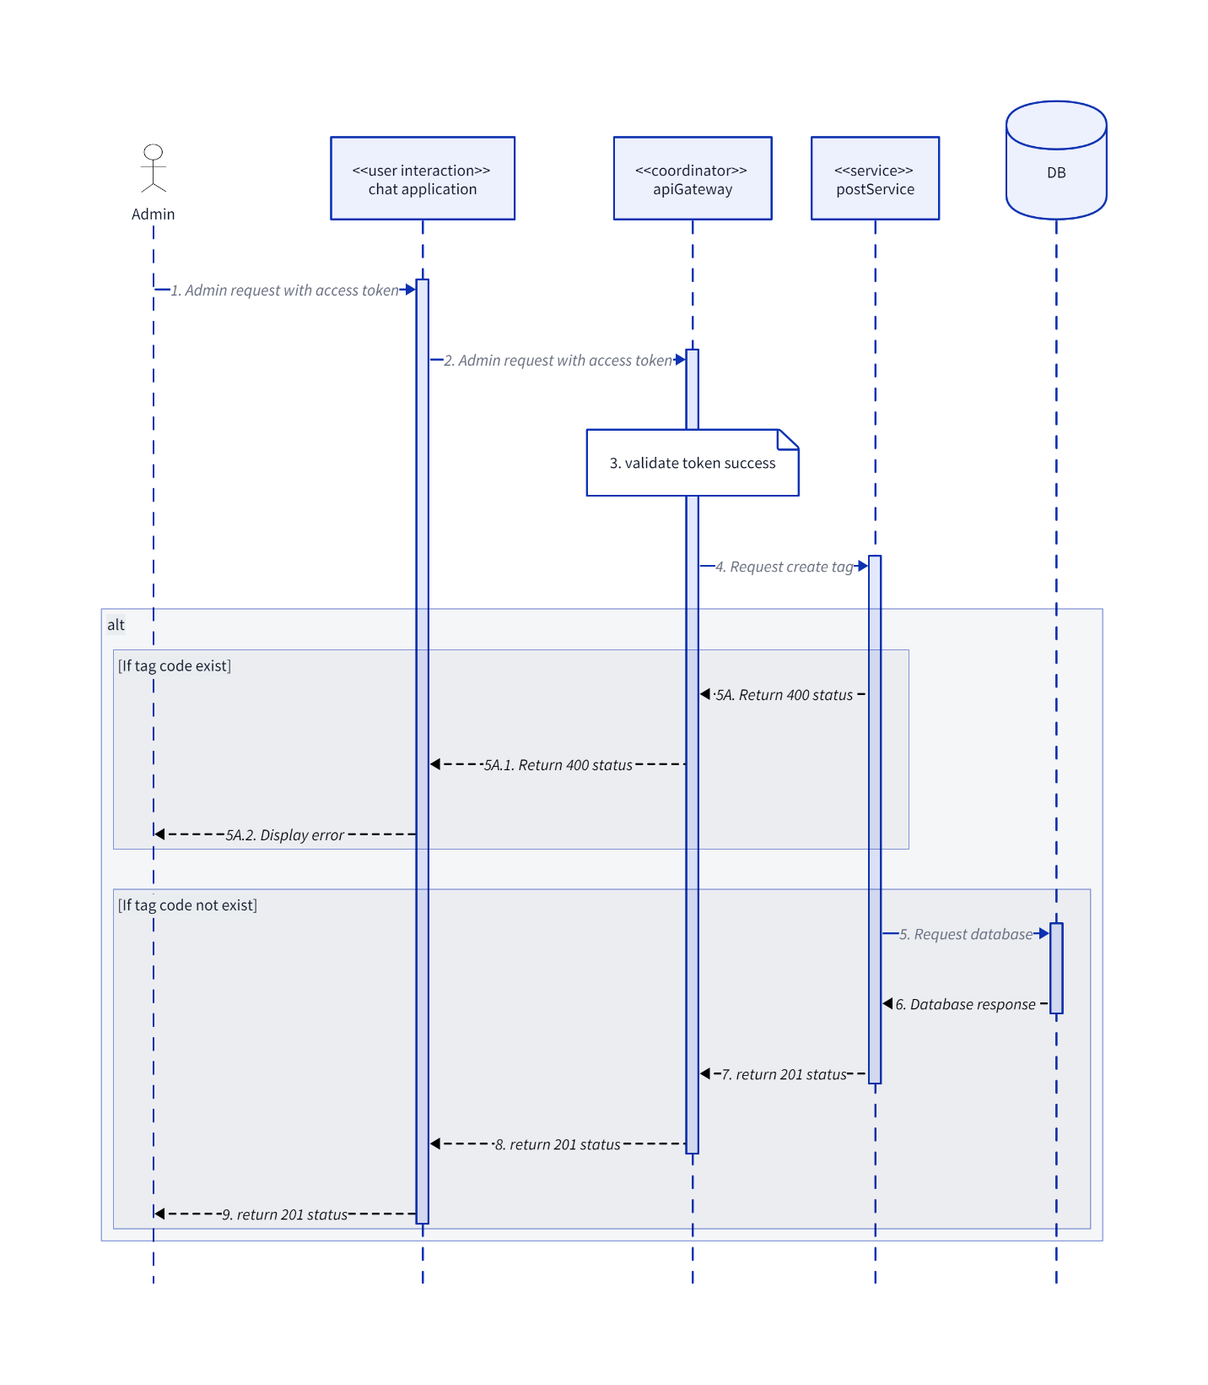

* + 1. **DeleteInteractionEmoji**

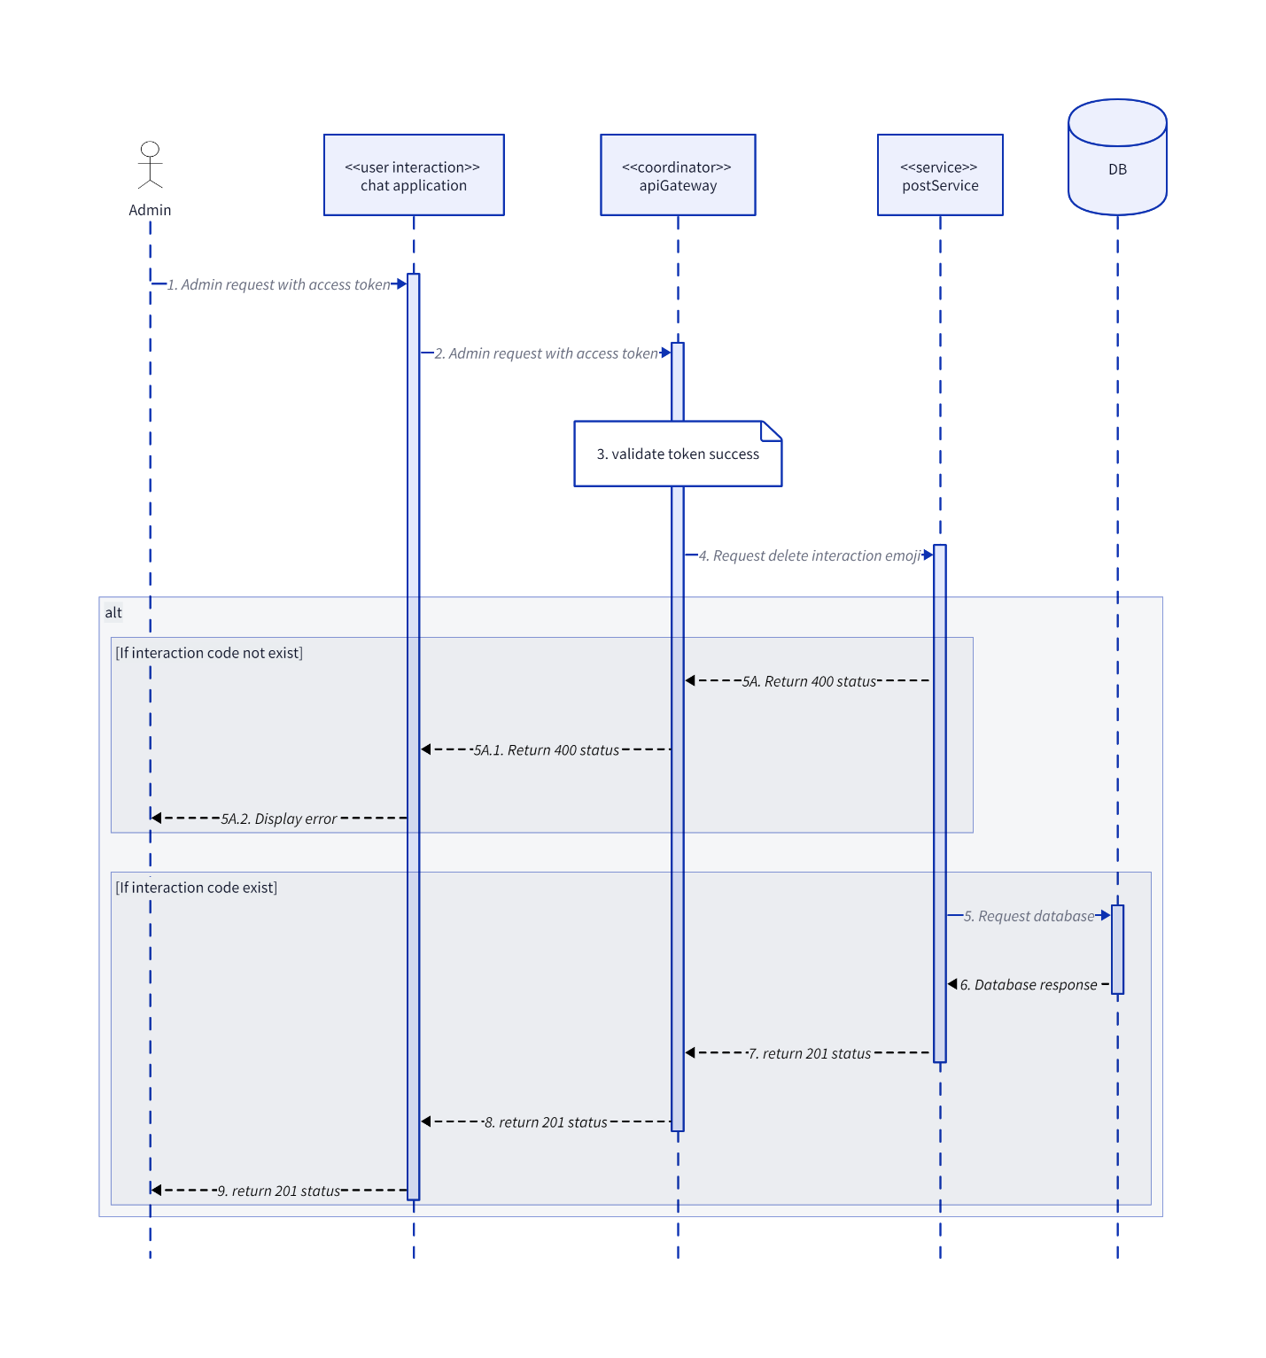

* + 1. **DeleteTag**

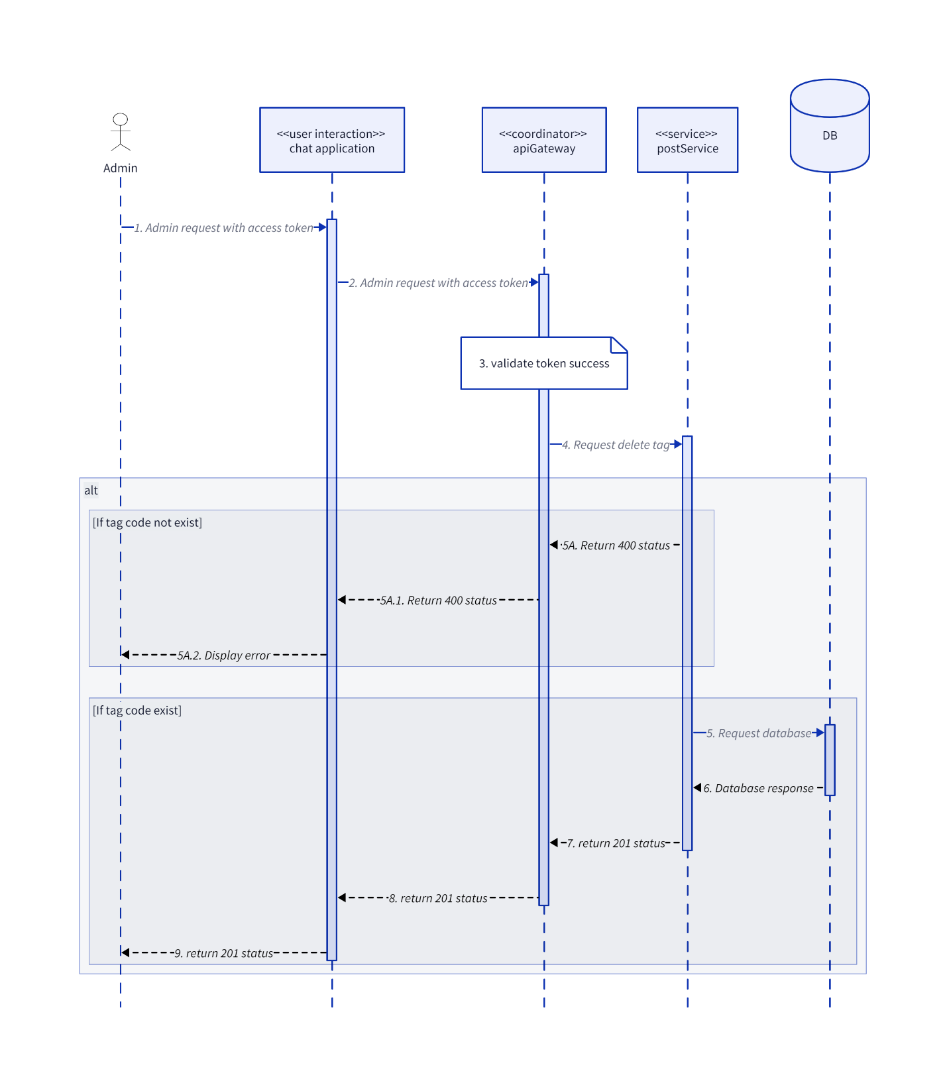

* + 1. **DisablePost**

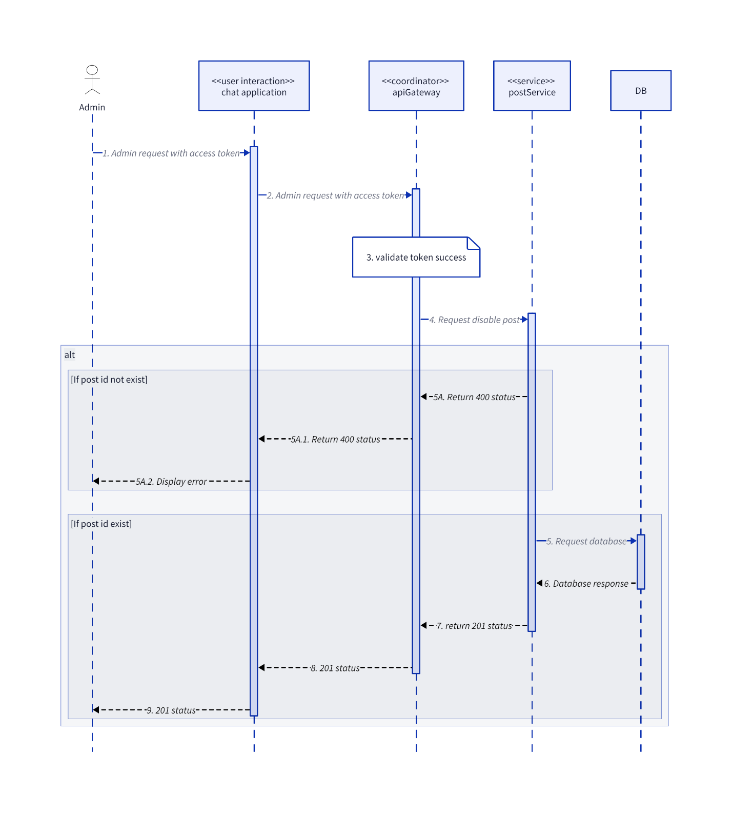

* + 1. **GetListInteractionEmoji**

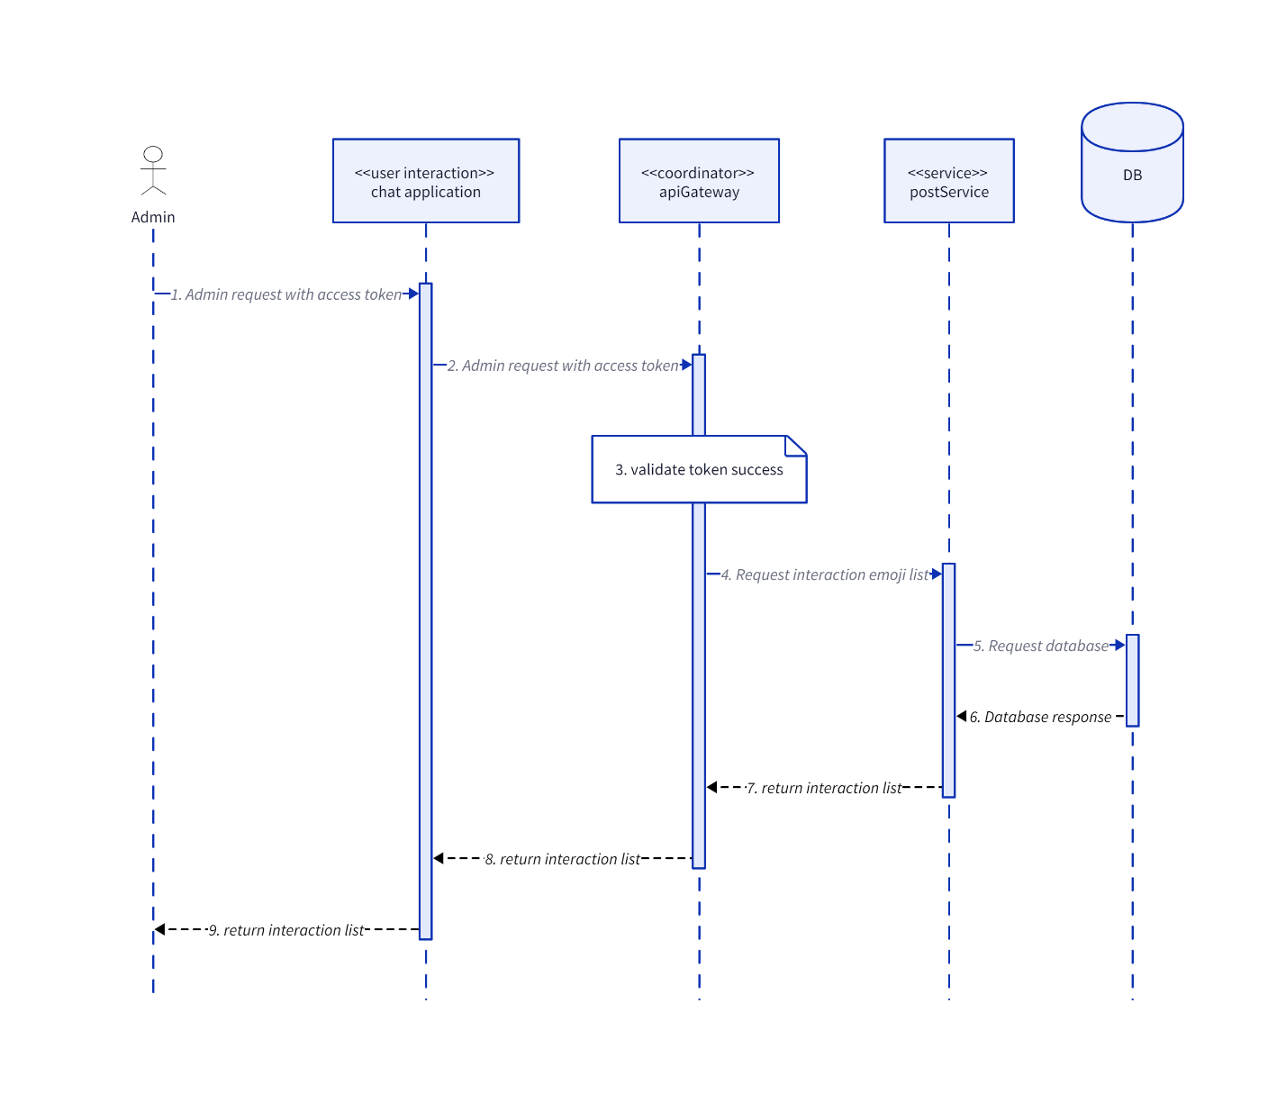

* + 1. **GetPostById**

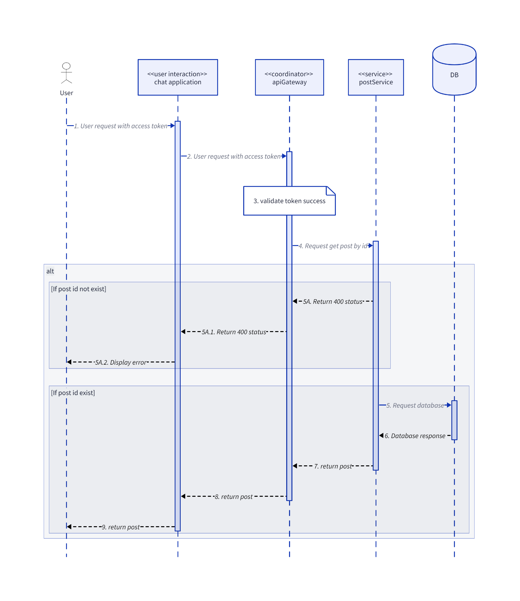

* + 1. **GetReportPostList**

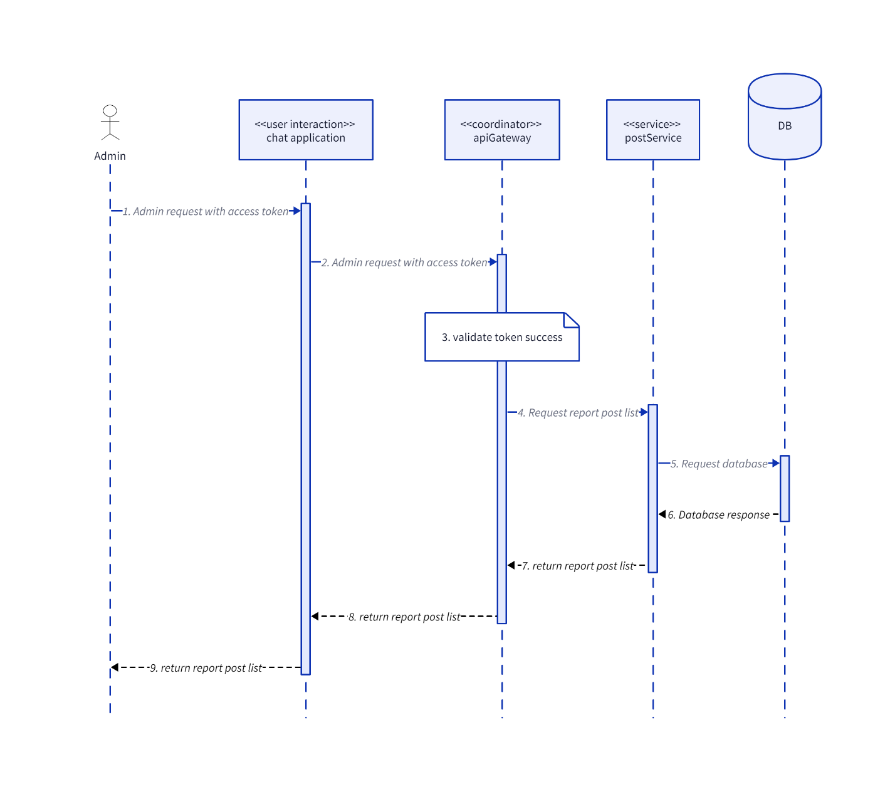

* + 1. **GetTagList**

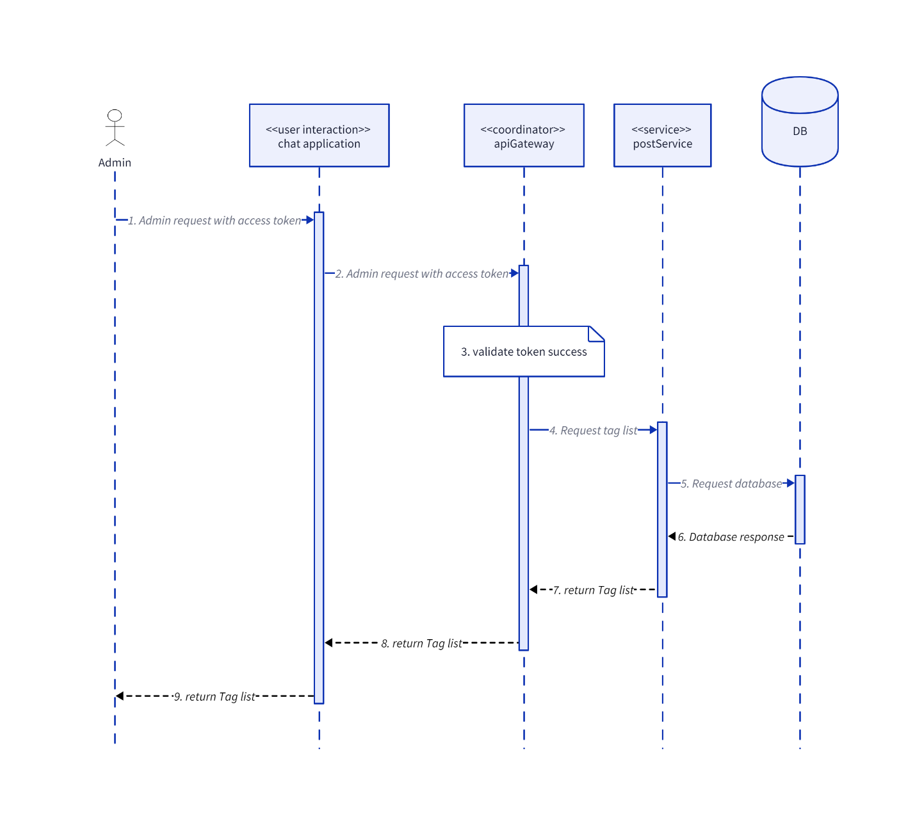

* + 1. **UpdateInteractionEmoji**

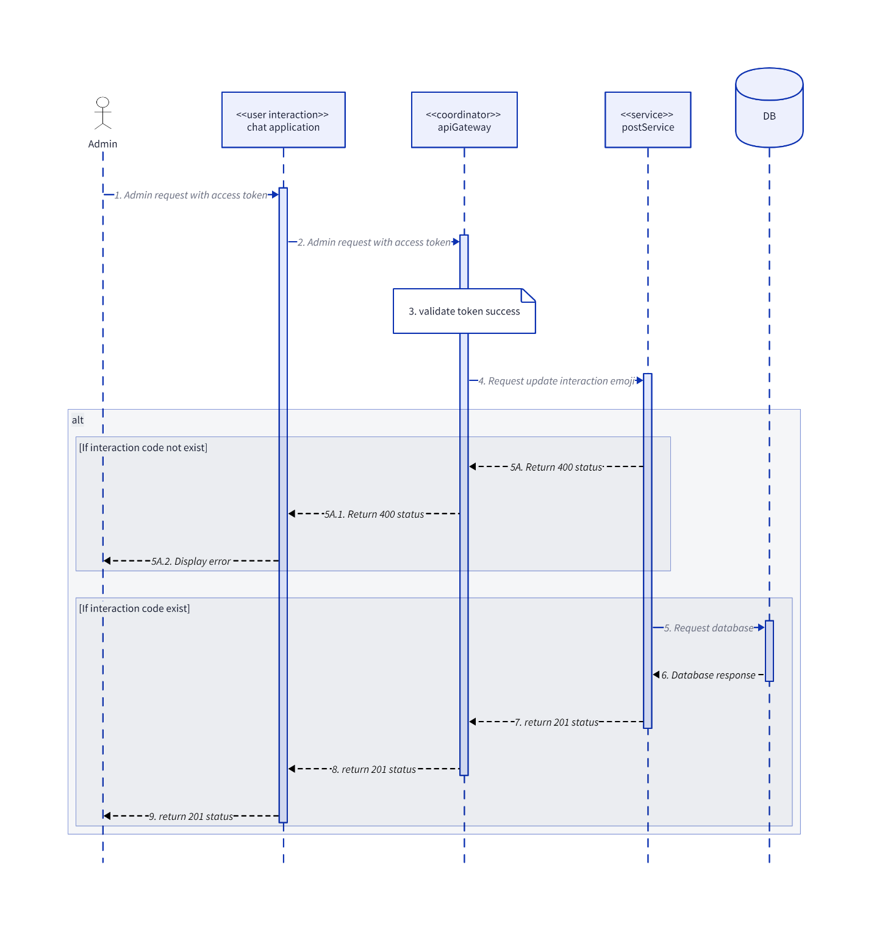

* + 1. **UpdatePost**

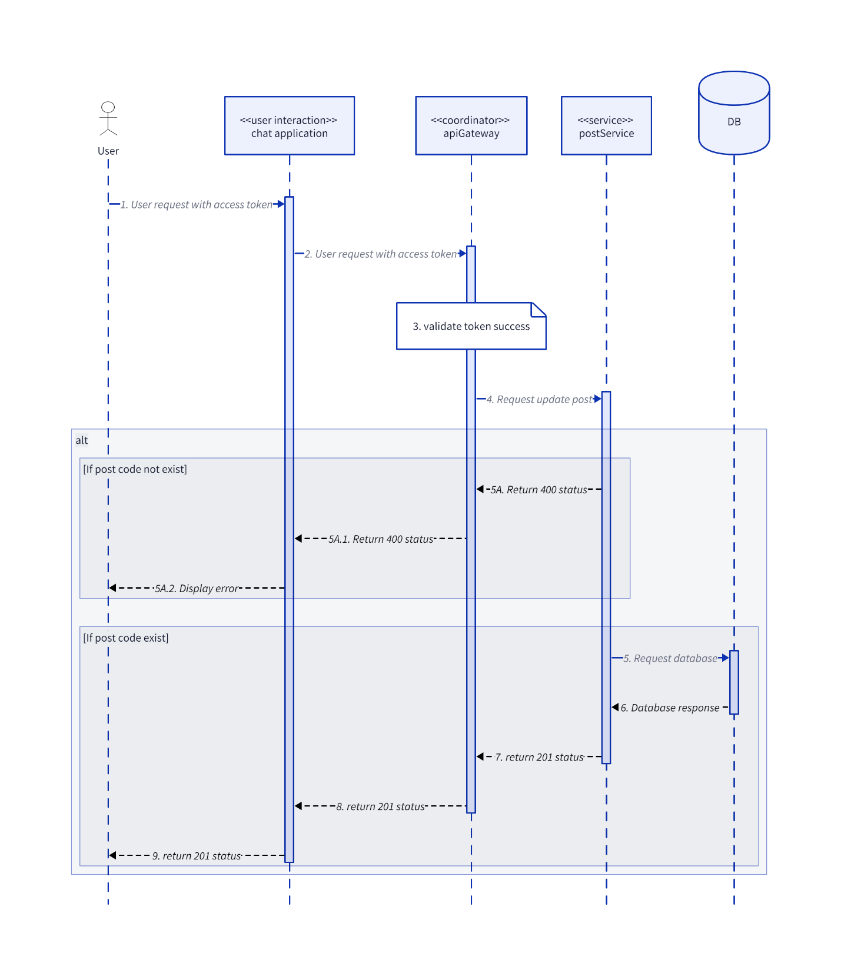

* + 1. **UpdateTag**

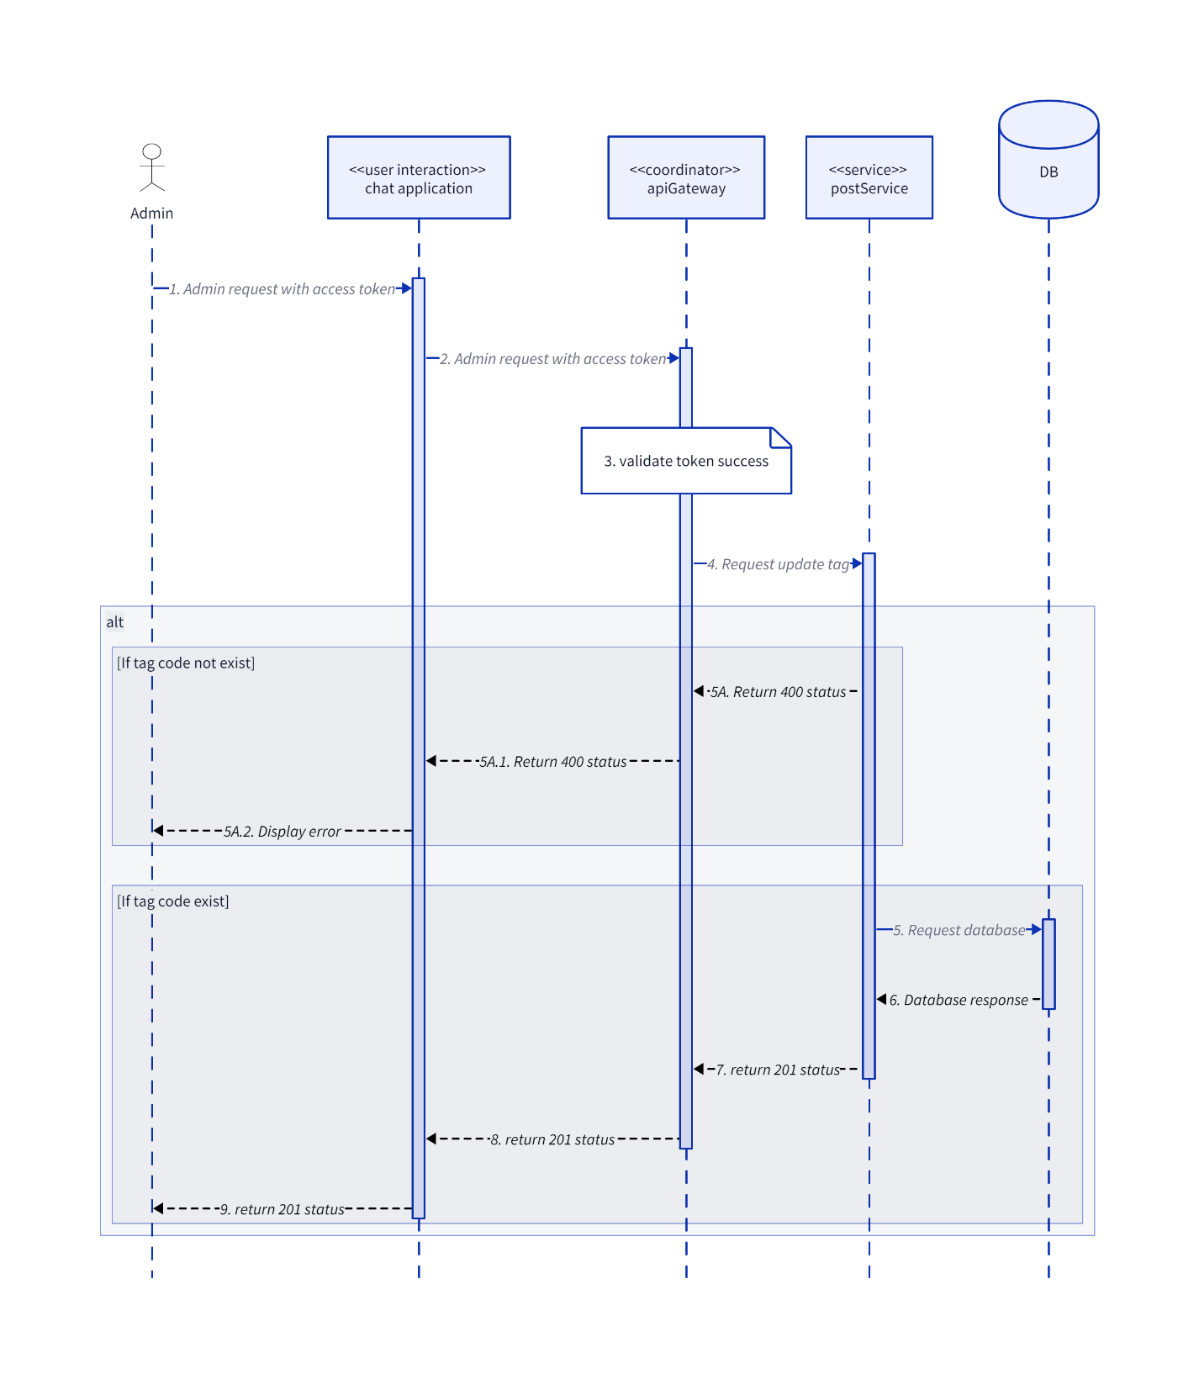

* 1. **Websocket**

**Call**

